DESIGN AND IMPLEMENTATION OF A MOTION-ACTIVATED REAL-TIME INTERACTIVE LED DEPARTMENTAL SCHEDULE DISPLAY

BY

ATAYI WISDOM
21/58437/UE
&
DEMKAA A. JOSHUA
21/58439/UE

DEPARTMENT OF ELECTRICAL AND ELECTRONICS ENGINEERING,
JOSEPH SARWUAN TARKA UNIVERSITY, MAKURDI.

NOVEMBER, 2026

DESIGN AND IMPLEMENTATION OF A MOTION-ACTIVATED REAL-TIME INTERACTIVE LED DEPARTMENTAL SCHEDULE DISPLAY

BY

ATAYI WISDOM 21/58437/UE
DEMKAA A. JOSHUA 21/58439/UE

A project report submitted to the Department of Electrical and Electronics Engineering, Joseph Sarwuan Tarka University, Makurdi, in partial fulfilment of the requirements for the award of the degree of Bachelor of Engineering (B.Eng.) in Electrical and Electronics Engineering.

NOVEMBER, 2026

DECLARATION
We declare that the work described in this report is original, and has not been submitted previously to any university or similar institution for the award of any degree or certificate.

Name of candidate: ATAYI WISDOM
Registration number: 21/58437/UE
Signature: …………………………………………………… Date: …………………………

Name of candidate: DEMKAA A. JOSHUA
Registration number: 21/58439/UE
Signature: …………………………………………………… Date: …………………………

CERTIFICATION
We, the undersigned, certify that this project report, presented by ATAYI WISDOM (21/58437/UE) and DEMKAA A. JOSHUA (21/58439/UE), is accepted as fulfilling part of the requirements for the award of the degree of Bachelor of Engineering in Electrical and Electronics Engineering.

Project Supervisor: ……………………………………………………
Signature / Date: ……………………………………………………

Project Coordinator: ……………………………………………………
Signature / Date: ……………………………………………………

Head of Department: ……………………………………………………
Signature / Date: ……………………………………………………

DEDICATION
This work is dedicated to the Almighty God, for His mercies every day and for sustaining us through this project, and to our families, whose patience and support made it possible.

ACKNOWLEDGEMENT
We return all honour and glory to God Almighty, whose hand has kept us through a process that seemed impossible at the start.
We express our heartfelt gratitude to our project supervisor, Engr. A. S. Iannah, for his commitment, his professional guidance and his constructive criticism throughout the research and the implementation. His technical depth and his insistence on evidence moulded this work and brought it to its present standard.
Our sincere appreciation goes to the Department of Electrical and Electronics Engineering, Joseph Sarwuan Tarka University, Makurdi, for the environment and the resources that supported the work, and to our lecturers and the departmental staff for their mentorship.
We thank our colleagues and friends whose suggestions and assistance enriched the design, and above all our families, whose moral support and belief in us remained a source of strength throughout.

TABLE OF CONTENTS

Right-click here and choose Update Field to build the contents list
Headings 1 to 3 are collected, with page numbers

LIST OF FIGURES

Right-click here and choose Update Field to build the list of figures
Every Figure caption in the document is collected

LIST OF TABLES

Right-click here and choose Update Field to build the list of tables
Every Table caption in the document is collected

LIST OF ABBREVIATIONS AND SYMBOLS
Abbreviation | Meaning
AP | Access point
BLE | Bluetooth Low Energy
CRC | Cyclic redundancy check
DS3231 | Temperature-compensated real-time clock
ESP32 | Espressif dual-core microcontroller with Wi-Fi and Bluetooth
GATT | Generic Attribute Profile
GPIO | General-purpose input/output
I²C | Inter-integrated circuit bus
JSON | JavaScript Object Notation
Li-ion | Lithium-ion
MTU | Maximum transmission unit
PIR | Passive infrared
RTC | Real-time clock
UUID | Universally unique identifier
WAT | West Africa Time (UTC+1)

ABSTRACT
This report presents the design and construction of a motion-activated, real-time interactive LED departmental schedule display for the Department of Electrical and Electronics Engineering, Joseph Sarwuan Tarka University, Makurdi. Timetables in the department are published on printed paper, which fades, tears, cannot be corrected without a reprint and cannot be filtered to a student's own level. The system described here replaces that sheet with a 64 × 20 iPixel Bluetooth Low Energy LED matrix driven by an ESP32 microcontroller over a Bluetooth GATT link, with no conductor between the controller and the panel. An HC-SR501 passive infrared sensor starts a session only when somebody is present, a DS3231 real-time clock supplies the time and day from which the greeting and the timetable entry are chosen, and a 4 × 4 keypad lets the student select an academic level, confirmed with # and cleared with *. The same ESP32 publishes its own Wi-Fi access point, on which a departmental administrator uploads a validated JSON timetable, sets the clock, previews any level and reads the state of the system, without any internet connection and without touching the unit. The controller is powered through a 2-in-1 lithium-ion charge and discharge module with a 4 000 mAh cell, which changes over without a relay, while the panel is powered from a separate 5 V, 2 A supply because it draws about six times the current of the controller. The completed unit detects a person at the distances required of a corridor, greets according to the hour, displays the classes of the selected level and day in a single scroll, returns to a stationary clock, and continues to operate while the mains supply is interrupted. The limitations of the approach — the font and single colour imposed by the panel controller, a 280-character message limit, and the sharing of the 2.4 GHz band between Bluetooth and Wi-Fi — are stated, and recommendations for their removal are given.

INTRODUCTION

Background of the Study
The effective dissemination of lecture schedules, course details and venue information is essential to the smooth academic progress of students in any higher education institution. In university departments across Nigeria, including those in Benue State, the traditional method of publishing lecture timetables has remained largely unchanged for decades: a printed sheet of paper is pinned to a departmental notice board at the beginning of each semester and is expected to serve for the whole term. That method suffers from poor visibility, rapid deterioration in a humid climate, and the difficulty of making a correction once the sheet has been printed and posted.
Modern embedded systems now make a better arrangement affordable. The ESP32 microcontroller combines a dual-core processor, ample flash memory and a 2.4 GHz radio that can act as either a Wi-Fi station or a Bluetooth Low Energy (BLE) peer, and it costs less than a printed banner. A passive infrared (PIR) sensor can start a display only when somebody is present, and a DS3231 real-time clock keeps the correct time and day without any network connection. On the display side, the class of LED matrix panels sold with an on-board Bluetooth controller (the iPixel family) has removed the difficult part of the problem: the panel stores the message, generates the characters and performs the scrolling itself, so the host has only to send a short string of text over a wireless link.
This project brings those parts together. A 64 × 20 iPixel BLE matrix is used as the display, and the ESP32 addresses it as a Bluetooth Low Energy client. The same ESP32 publishes a Wi-Fi access point of its own, on which a departmental administrator can open a web page and upload a new timetable without touching the unit and without any internet connection. A 4 × 4 keypad lets a student select an academic level, a passive buzzer acknowledges the entry, and a rechargeable lithium-ion supply keeps the controller alive during the mains interruptions that are routine in Makurdi. The result is a display that is legible across a corridor, aware of the time and day, filtered to the student's own level, and updateable from a phone.
The work proceeds in the conventional order. The technologies involved are reviewed first, then each subsystem is analysed electrically and its component values are justified, then the prototype is constructed and tested subsystem by subsystem, and finally the completed system is evaluated against the objectives set out below.

Statement of the Problem
The Department of Electrical and Electronics Engineering, like most departments of Joseph Sarwuan Tarka University, Makurdi, communicates its lecture timetable on printed paper pinned to a notice board. The sheet is read by students of five academic levels, each of whom has to scan the whole departmental timetable to find the few classes that concern them. The paper fades and tears, a change of venue or time requires a reprint and a walk to the board, and the display is unreadable from the far end of the corridor. Electronic alternatives are rarely adopted because a screen that has no backup supply simply goes blank during the frequent outages in the region, and because a display that must be reprogrammed on the spot to change a timetable is no easier to administer than paper.
There is therefore a need for a departmental schedule display that is large and clearly visible, that shows the correct information for the current day and hour without intervention, that lets a student see only the classes of his or her own level, that can be updated remotely over a network the device creates itself, that wakes only when somebody is present to read it, and that continues to run while the mains supply is interrupted.

Aim of the Study
The aim of this study is to design and construct a motion-activated, real-time interactive LED departmental schedule display in which an ESP32 microcontroller drives a 64 × 20 iPixel Bluetooth Low Energy LED matrix and also serves the web page from which the timetable is maintained.

Objectives of the Study
The specific objectives of this study are:
To design a motion-activated LED departmental schedule display using an ESP32 microcontroller and a 64 × 20 iPixel BLE LED matrix addressed over a Bluetooth Low Energy link, with PIR-based presence detection and a DS3231 real-time clock for automatic, time-correct display.
To develop an interactive interface through which a student filters the timetable by academic level on a 4 × 4 keypad, and through which an administrator uploads a new timetable to a web page served by the ESP32 on its own Wi-Fi access point, sets the clock and inspects the state of the system.
To ensure reliable and continuous operation through persistent storage of the timetable in ESP32 flash memory and a rechargeable lithium-ion backup supply that changes over automatically when the mains fails.

Significance of the Study
The project demonstrates that a schedule display of this class can be built from parts that are available in any Nigerian electronics market, and that the difficult parts of the problem — driving a large matrix, keeping time, and publishing a web page — are all handled by inexpensive modules. For the department, the display removes the printing and posting of timetables, allows a correction to be published from a phone in a minute, and keeps working during an outage. For students, it turns a single departmental timetable into five level-specific messages that can be read from several metres away. For the wider field, it is a documented example of a Bluetooth-controlled display driven by a microcontroller that also serves its own configuration interface, which is the arrangement most low-cost campus displays will use as the panels become cheaper.

Scope of the Study
The system is built around an ESP32 NodeMCU-32S development board. The display is an iPixel LED matrix of 64 columns by 20 rows, that is 1 280 pixels, with an on-board Bluetooth Low Energy controller, an internal flash memory in which messages are stored, and a USB-C socket through which it is powered. The panel is addressed as a BLE peripheral: the ESP32 scans for it, connects as a client, discovers the write characteristic at 0xFA02 and the notify characteristic at 0xFA03, and streams the characters of the message to it. No signal conductor runs between the ESP32 and the panel. The panel is powered from the 5 V rail of the project itself, through a branch taken from the output of the lithium-ion module to its USB-C socket; it is not fed from the 5V or 3V3 pin of the ESP32 board, because it draws about 1.5 A when it is showing a message and no pin of the board can supply that.
A PIR sensor (HC-SR501) on GPIO27 detects a person and starts a session. A DS3231 real-time clock with a CR2032 backup cell keeps Nigerian local time, UTC+1, and communicates over I²C on GPIO21 and GPIO22. A student enters a level of 100L to 500L on a 4 × 4 matrix keypad, whose rows are GPIO13, GPIO12, GPIO14 and GPIO33 and whose columns are GPIO32, GPIO26, GPIO25 and GPIO19; the # key confirms an entry, the * key clears it, and a passive buzzer on GPIO15 acknowledges every accepted key. The timetable itself is a JSON file held in the LittleFS partition of the ESP32 and validated before it replaces the previous file. It is uploaded through a web page served by the ESP32 at 192.168.4.1 on its own access point; the ESP32 may also be joined to a departmental router as a client, which supplies network time, but no function of the display depends on that router.
The controller is supplied from a 5 V USB adapter through a 2-in-1 lithium-ion charge and discharge module holding a 4 000 mAh cell, which changes the load over to the cell without a relay when the mains fails. The system holds the complete weekly timetable of five levels for one department, shows the classes of one level and one day as a single scrolling message of up to 280 characters, and is intended for indoor use in a corridor or above a departmental notice board.

LITERATURE REVIEW

Theoretical Framework
The design of this display rests on four bodies of knowledge: short-range wireless communication in the form of Bluetooth Low Energy, matrix LED display modules that accept text rather than pixels, embedded web servers running on a microcontroller, and battery-backed power conversion. Each is reviewed below in the form in which it is used in this project, followed by the empirical studies from which the design decisions were taken.

Bluetooth Low Energy and the GATT Profile
Bluetooth Low Energy is a short-range radio protocol operating in the 2.4 GHz industrial, scientific and medical band. Unlike the original Bluetooth, which holds a connection open with a fixed slot structure, BLE is built for intermittent transfer: a device advertises its presence on three dedicated channels, a client connects to it, and the two then exchange packets at a negotiated connection interval that may be as short as 7.5 ms and as long as four seconds. The data themselves are organised in the Generic Attribute Profile (GATT), in which a server exposes services, each service contains characteristics, and each characteristic carries a value that a client may read, write, or subscribe to by notification (Bluetooth SIG, 2023).
Three properties of BLE matter for a display of this kind. The first is that the protocol is asymmetric: the panel is the server, holding the characteristics, and the ESP32 is the client, so all commands travel as writes to a single characteristic and any acknowledgement arrives as a notification. The second is that the maximum length of a single write is fixed by the negotiated Maximum Transmission Unit (MTU); a default MTU of 23 bytes leaves 20 bytes of payload, whereas an MTU of 517 leaves 514, which is why a long message must be fragmented and why the MTU is negotiated at connection. The third is that BLE shares the 2.4 GHz band with Wi-Fi, so a device that runs both, as the ESP32 does here, must time-share a single radio between the two protocols and will show occasional latency when both are busy.

iPixel Bluetooth Low Energy LED Matrix Panel
The display used in this project belongs to the family of flexible LED matrix panels sold under the iPixel Color application and its rebrands. The panel is a printed circuit board carrying 1 280 addressable RGB LEDs in 20 rows of 64, a controller that holds a font, a frame buffer and a small flash memory, and a Bluetooth Low Energy transceiver. It is not a pixel-addressable matrix in the sense of a HUB75 panel or a WS2812B chain: the host sends a character string, and the controller renders it, stores it in one of nine message slots and scrolls it across the field at a speed supplied with the message. The panel used here is the HRP-1696, the 64 × 20 member of the family: its active area is 12.59 × 3.15 inches (320 × 80 mm), it is built on a flexible substrate, and the protocol identifies its size class by a type byte in the device information, which for the 64 × 20 unit reports the 1 280-pixel field (cagcoach, 2024). It is supplied at 5 V through a USB-C socket and draws up to 2 A when the whole field is lit, which in this project is taken from the same 5 V rail that feeds the controller.
The protocol spoken by the panel has been documented by the community that reverse-engineered it. The service is 0x00FA; commands are written to characteristic 0xFA02 and acknowledgements and replies arrive on 0xFA03, which the client enables by writing 0x0100 to its client configuration descriptor. A message is framed as a 16-bit little-endian length, a 16-bit command, a 32-bit payload length, a 32-bit CRC of the payload, a slot number and a group of display parameters, followed by the payload itself, which for text is a run of 20-byte records describing successive eight-column tiles of the rendered bitmap (yyewolf, 2025; cagcoach, 2024). Brightness is a five-byte command, power is another, and the device reports its panel size, firmware version and whether it also carries a Wi-Fi module when the appropriate query is sent.
Two consequences follow for this project. Because the controller owns the font, the character set and the scroll, the firmware cannot choose a typeface or place a character at an arbitrary pixel, and the colour of the text is set by the message rather than by the program. Because the whole message is uploaded before it is displayed, the length of a message is limited by the memory of the controller rather than by the patience of the reader, which is why the firmware of this project refuses a message longer than 280 characters.
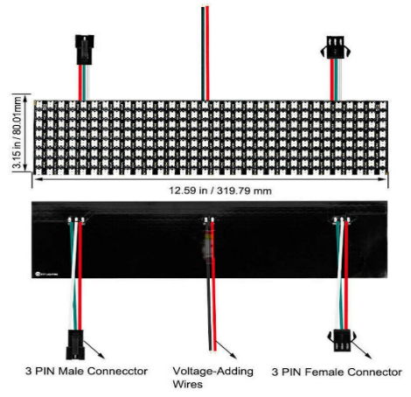
Figure 2.1: iPixel 64 × 20 Bluetooth Low Energy LED Matrix Panel

ESP32 Microcontroller
The ESP32 is a system-on-chip designed by Espressif Systems around a dual-core Xtensa LX6 processor running at up to 240 MHz, with 520 kB of static RAM, a flash memory of 4 MB or more on the module, and a single 2.4 GHz radio that serves both Wi-Fi (802.11 b/g/n) and Bluetooth Low Energy. It provides 34 general-purpose input and output pins, of which some are reserved for flash memory, some are input-only, and a few determine the boot mode at reset. Its peripherals include two independent I²C controllers, several serial and SPI controllers, a CAN controller and a rich set of timers (Espressif Systems, 2023). The display of this project uses none of them, because the panel is addressed over the radio, and only the I²C controller and the GPIO pins are used by the rest of the system.
The dual-core architecture is directly useful here. One task can hold the BLE connection and stream the message to the panel, a second can run the web server and the file system, and the main loop can scan the keypad and watch the PIR sensor, without any one of them blocking the others for longer than a few milliseconds. The same radio serving both protocols is the principal constraint of the design, because a Wi-Fi upload and a BLE transmission cannot proceed at the same instant; the firmware therefore handles web requests between messages rather than during one.
Table 2.1: Key Parameters of the ESP32 Module Used in the Design
Parameter | Value
Processor | Dual-core Xtensa LX6, up to 240 MHz
Static RAM | 520 kB
Flash memory | 4 MB on the module, shared by program and LittleFS
Wi-Fi | 802.11 b/g/n, 2.4 GHz, access point and station
Bluetooth | Bluetooth 4.2 Low Energy, GATT client and server
GPIO | 34 pins, 3.3 V logic, 12 mA continuous per pin
I²C / serial / SPI controllers | 2 / 3 / 4
Supply | 5 V at the VIN pin, 3.3 V regulated on board
Active current | about 250 mA with the radio transmitting, 0.15 mA in deep sleep

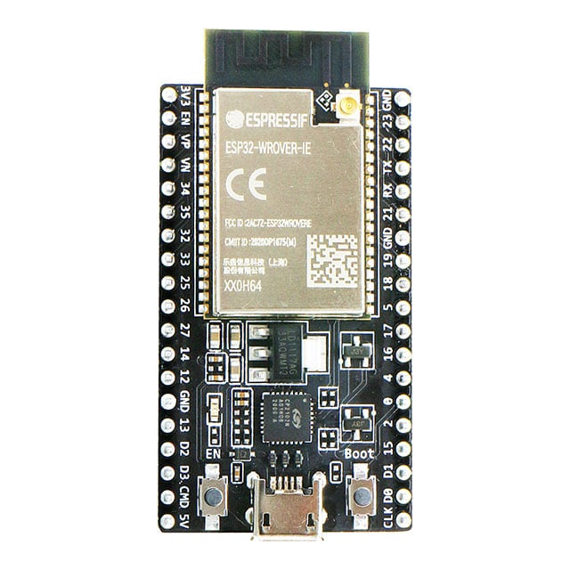
Figure 2.2: ESP32 NodeMCU-32S Development Board

Passive Infrared Motion Sensor (HC-SR501)
A passive infrared sensor detects the change in infrared radiation that occurs when a warm body moves across its field of view. The HC-SR501 module pairs a pyroelectric element with a Fresnel lens that divides the field into alternating zones, so that a person walking past produces a sequence of positive and negative transitions at the element. The module contains its own comparator, a monostable that holds the output high for a settable time of about three seconds to five minutes, and two potentiometers, one for sensitivity and one for the hold time. Its output is a 3.3 V logic signal that can be taken directly to a microcontroller pin (Mashrur, 2025).
The sensor is used here only to start a session, so its hold time is set to its minimum and the duration of the session is controlled by the firmware. Its sensitivity is set so that a person approaching the display is detected at about four metres, which is the width of the corridor in which the unit is intended to be mounted, while movement in the adjacent room is not.
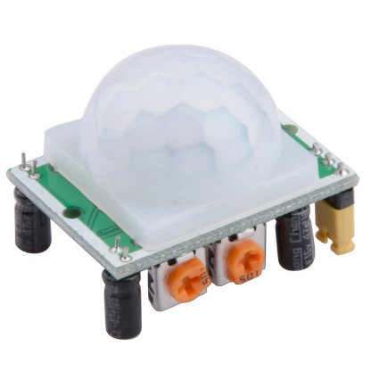
Figure 2.3: HC-SR501 Passive Infrared Motion Sensor

DS3231 Real-Time Clock
The DS3231 is a temperature-compensated real-time clock. It contains a 32.768 kHz crystal, a temperature sensor and compensation circuitry that trims the oscillator, so that the time it keeps drifts by about two minutes a year at room temperature, far better than the few minutes a month of an uncompensated clock. It communicates over I²C at address 0x68, holds seconds, minutes, hours, day, date, month and year in binary-coded decimal, accounts for leap years up to 2100, and can raise an alarm at a programmed time. The module used here carries the chip, a CR2032 coin cell that keeps it running when the system is switched off, and 4.7 kΩ pull-up resistors on the two bus lines (Analog Devices, 2015).
The display depends on this device for two things: the greeting, which changes at noon and at five o'clock, and the day of the week, by which the timetable entry is selected and by which a weekend is recognised. Because the clock is read once a second and the module answers in well under a millisecond, the bus is not a bottleneck, and because the coin cell keeps the count during an outage the system comes back with the correct time even after the main battery has been exhausted.
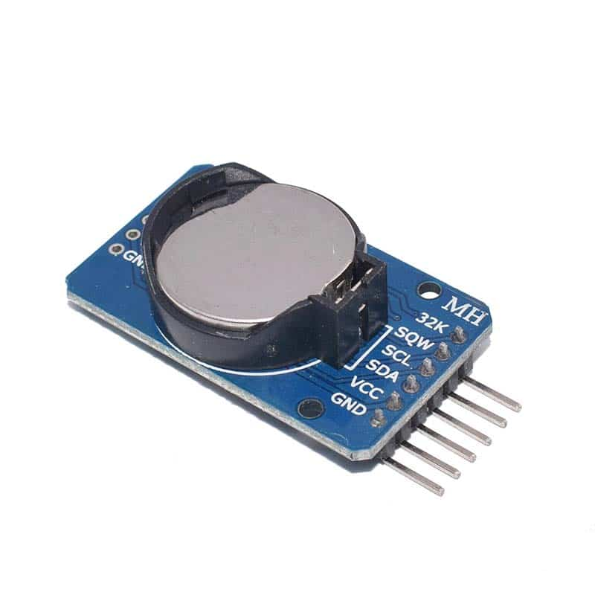
Figure 2.4: DS3231 Real-Time Clock Module

4 × 4 Matrix Keypad
A matrix keypad arranges sixteen switches at the intersections of four rows and four columns, which reduces the number of conductors from seventeen to eight. The microcontroller drives one column low at a time, holds the rows high through internal pull-up resistors, and reads the rows; the row that goes low while a column is driven identifies the key. Only one column is driven at a time so that two keys pressed together cannot connect an output to ground, and the scan is filtered in time so that the contact bounce of a membrane keypad, which lasts ten to twenty milliseconds, is not read as several presses (Ifeagwu, 2025).
In this project the keypad carries the only input that the student provides: three digits of the academic level, confirmed with # and cleared with *. It is deliberately not used for administering the timetable, because a departmental timetable contains far more text than sixteen keys can conveniently enter; that is done on the web page described below.
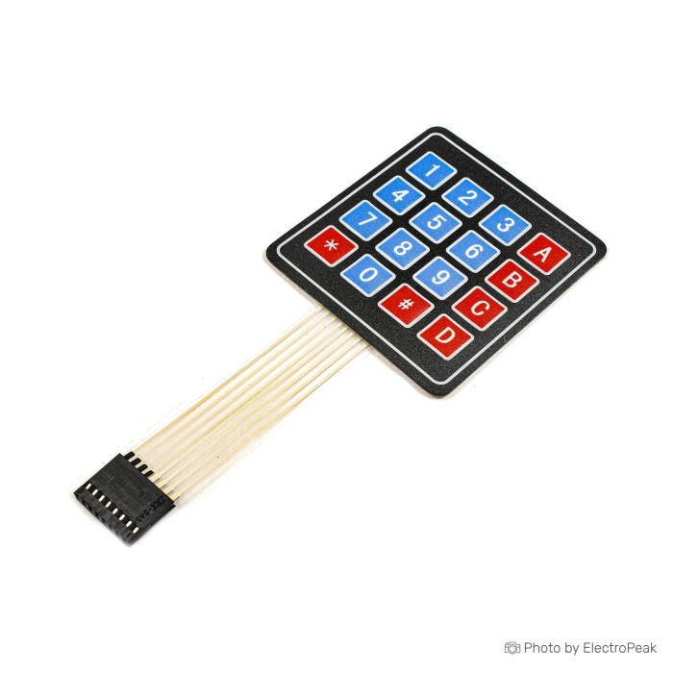
Figure 2.5: 4 × 4 Matrix Membrane Keypad

Wi-Fi Access Point and Embedded Web Server
The ESP32 can act as a Wi-Fi access point in its own right: it beacons a network name, allocates addresses through its own DHCP server, and answers at 192.168.4.1 by default. A web server running on the microcontroller can therefore serve a page to any phone or laptop within range without a router, an internet connection or a cloud service. The same radio can also be joined to an existing network as a client, in which case the page becomes reachable from that network and the device can take its time from a network time server, while the access point continues to operate (Triwahyuni & Beta, 2022).
This arrangement suits a departmental corridor, where the institutional network may be absent for days. The administrator walks up with a phone, joins the network that the display publishes, opens the page and uploads the new timetable file. The page is stored compressed in the program memory of the ESP32 and the upload is streamed to the file system in fragments, so that a complete departmental timetable can be received without holding it in RAM. The uploaded file is parsed and validated in full before it replaces the working copy, so that a mistake made in a text editor cannot destroy a timetable that is in use.

Backup Power for the Two Loads
The system contains two loads that must survive an outage. The controller, the sensor, the keypad and the buzzer together draw about a quarter of an ampere at 5 V. The display panel draws roughly six times that, and although it is a self-contained unit with its own controller and flash memory, it is fed from the same rail as everything else. The design therefore uses one supply for the whole system: a 5 V, 4 A adapter with a 2-in-1 lithium-ion charge and discharge module and a 4 000 mAh cell, from whose output two branches are taken, one to the controller side and one to the USB-C socket of the panel.
Sharing the rail has three advantages. One adapter and one mains lead serve the whole display, which is what a unit mounted on a corridor wall requires. The cell then carries the display as well as the controller, so a message already on the panel and the timetable held in the controller both survive an outage together instead of one outliving the other. And the rail is loaded predictably, at about 1.9 A in the worst case against a 4 A adapter, so the pulsed current of a scrolling message is drawn from a supply with real headroom rather than from one at its limit. The cost is that the backup time of the whole display is set by the heavier load, the panel, and is therefore shorter than the controller alone would give; the figures are calculated in Section 3.10.4 and measured in Section 4.4.2.

Conceptual Framework
The system is organised as an input–process–output arrangement of five subsystems coordinated by a state machine on the ESP32. The inputs are human presence from the PIR sensor, the time and day from the DS3231, the academic level from the keypad, and the timetable file uploaded over the access point. The process is the lookup of the classes of that level and day in the timetable file, their formatting into a single string of course code, time and venue, and the transmission of that string over the Bluetooth Low Energy link. The output is the scrolling message on the panel. The power subsystem underpins all of it, providing 5 V to the controller, the sensor and the buzzer, 3.3 V to the clock, and a separate 5 V supply to the panel.
Two boundaries in this framework deserve emphasis because they shape every other decision. The first is the boundary between the controller and the panel, which is a radio link and therefore carries no power and no ground: the ESP32 can say what the panel should show, but it cannot sense whether the panel is lit, and it must recover from a lost connection by itself. The second is the boundary between the panel and the departmental timetable, which is the panel controller's own font and scroll: the firmware decides the words and the order, but the typeface, the letter spacing and the speed of the scroll belong to the panel. The design is honest about both boundaries, and the limitations they impose are recorded in Chapter Four.

Review of Related Empirical Studies
Hercog et al. (2023) examined the design of ESP32-based devices for the industrial internet of things and reported that the dual-core architecture allows communication and control tasks to run concurrently without measurable interference. Their measurements of task latency informed the division of work in this project between the BLE task, the web server and the main loop.
Ogunseye et al. (2021) constructed a microcontroller-driven moving-message display and showed that an LED matrix is an effective replacement for a printed notice board in an institution, but their unit required a physical connection to change the message. The absence of a wireless update route is the gap that the access point of this project fills.
Zaghlool Mahmood (2022) combined an ESP32 with a DS3231 to automate a school bell, and demonstrated that a compensated real-time clock is accurate enough to drive a schedule without a network. The present design borrows that arrangement, and adds the display of the schedule itself rather than only the signalling of its moments.
Sarkar et al. (2023) built an IoT performance display around the ESP32 and reported that the microcontroller can render a display and serve a network at the same time provided that the display work is delegated to a driver rather than performed pixel by pixel in the main loop. The iPixel panel used here takes that delegation to its limit, since the panel performs the rendering as well.
Ranasinghe and Herath (2023) and Sulartopo et al. (2023) both used PIR sensors with an ESP32 for presence detection, and both reported reliable detection at ranges of three to five metres with few false events when the sensor was mounted at head height and away from a window. The mounting arrangement and the sensitivity setting adopted in Chapter Three follow their experience.
Margapuri (2020) compared PIR detection with other low-cost presence methods and concluded that the passive infrared sensor remains the cheapest reliable option for indoor use, at the cost of insensitivity to a person who is stationary. That limitation is acceptable here because the display is read by somebody who has just walked up to it.
Mashrur (2025) demonstrated motion-operated LED lighting and quantified the energy saved by lighting only when a person is present. The same argument applies to the session structure of this project, in which the panel leaves its stationary clock and shows a timetable only after a detection.
Ifeagwu (2025) described a Wi-Fi-enabled digital notice board in which content is pushed from a browser to an ESP32, and emphasised that the absence of a separate server is what makes such a board affordable and maintainable. The access point and the embedded page of this project follow the same principle.
Triwahyuni and Beta (2022) reported a running-text information system for small businesses in which the text is edited over a local network and displayed on a scrolling panel. Their work is the closest published relative of the present design, and it differs in two respects that matter: their panel was wired to the controller, and their text was entered rather than looked up from a validated timetable.
Vales et al. (2024) and Krebs and Herter (2024) explored time synchronisation and ranging with the ESP32 radio, and their results are a reminder that the 2.4 GHz radio is a shared resource whose behaviour changes when two protocols are used at once. That observation shaped the decision to keep web traffic out of the middle of a BLE transmission.
Sanap et al. (2025) documented the interfacing of a DS3231 to a microcontroller in detail, including the pull-up requirement of the I²C bus and the handling of the coin cell, and their treatment is used in Section 3.7 below.

Summary of Literature Review
The literature establishes four points. The ESP32 is a capable host for a display that must also serve a network, provided that the rendering is delegated. A compensated real-time clock makes a schedule display independent of the network. Passive infrared detection is a cheap and reliable way to start a display only when it is needed. And embedded web servers on the microcontroller have made the wireless update of a display's content an ordinary rather than an exotic feature.
The gap that remains is one of combination and of medium. The published campus displays either wire the panel to the controller, or drive a pixel-addressable matrix whose rendering the controller must perform itself, or update their content from a cloud service. None of the studies reviewed drives a commercially available Bluetooth LED matrix from an ESP32 that simultaneously publishes the page from which the timetable is maintained, and none validates the uploaded timetable before it is used. The present work addresses that combination, and documents the engineering consequences of putting the display behind a radio link rather than behind a wire.

CIRCUIT ANALYSIS AND DESIGN

Introduction
This chapter presents the electrical analysis and the design of each subsystem of the motion-activated LED departmental schedule display. Two questions are answered for every part: how were its values determined, and why was it chosen over its alternatives? The system comprises the ESP32 microcontroller as the controller, an iPixel 64 × 20 Bluetooth Low Energy LED matrix as the display, an HC-SR501 PIR sensor, a DS3231 real-time clock, a 4 × 4 matrix keypad, a passive buzzer, and one power arrangement: a 5 V adapter with a lithium-ion charge and discharge module and a cell, from which the controller and the panel are fed by separate branches of the same rail.

ESP32 Microcontroller as the Controller
The ESP32 was selected on four counts: its dual-core 240 MHz processor, its combined Wi-Fi and Bluetooth Low Energy radio, its flash memory, which is large enough to hold the web page, the dashboard assets and a complete departmental timetable, and its cost. A single-core Arduino Mega 2560 was rejected because it has neither a radio nor enough program memory for the page, and an Arduino Uno with a separate Bluetooth module was rejected because a second processor would have to be interfaced and powered. The ESP32 operates at 3.3 V logic, with an absolute maximum of 3.6 V on any pin, and 12 mA of continuous current per pin.
The choice of radio matters more than the choice of processor. The panel is a Bluetooth peripheral, so the controller must be a Bluetooth client; the administration page must be served over Wi-Fi, so the controller must be an access point. The ESP32 is one of very few inexpensive devices that can be both at once, and the firmware of this project uses the qualification that comes with that: the radio time-shares between the two protocols.

GPIO Pin Allocation
The pin assignment was decided by five constraints: the fixed functions of the I²C bus and of the strapping pins, the need for internal pull-ups on the keypad rows, the exclusion of the input-only pins GPIO34 to GPIO39, the desire to keep the pins used by the USB serial port free for the Serial Monitor, and the requirement that no pin be shared between two peripherals. The complete allocation is given in Table 3.1.
Three points in the table deserve comment. GPIO21 and GPIO22 are the hardware I²C pins and are used for the clock because a silicon implementation of the bus is more tolerant of bus capacitance than a software one. GPIO12, GPIO13, GPIO14 and GPIO15 are strapping pins whose level is read at reset; of these, GPIO12 selects the flash voltage and must not be pulled up at start-up, which is why it drives a keypad row that idles high through the internal pull-up only after the boot has completed, and GPIO15 is used for the buzzer because the buzzer is driven only after the system is running. GPIO34 to GPIO39 were not used at all, because they are input-only and have no internal pull-up, so a keypad scanned in the usual way cannot use them.
Table 3.1: GPIO Pin Allocation of the ESP32 Controller
GPIO | Direction | Connected to | Function | Design note
GPIO27 | Input | HC-SR501 OUT | Motion detection | Interrupt on a rising edge
GPIO21 | I²C SDA | DS3231 SDA | Clock data line | 4.7 kΩ pull-up on the module
GPIO22 | I²C SCL | DS3231 SCL | Clock line | 4.7 kΩ pull-up on the module
GPIO13 | Input, pull-up | Keypad row 1 | Row read during scan | Bidirectional pin
GPIO12 | Input, pull-up | Keypad row 2 | Row read during scan | Strapping pin, read at reset
GPIO14 | Input, pull-up | Keypad row 3 | Row read during scan | Bidirectional pin
GPIO33 | Input, pull-up | Keypad row 4 | Row read during scan | No special function
GPIO32 | Output | Keypad column 1 | Column driven low | High impedance when not scanned
GPIO26 | Output | Keypad column 2 | Column driven low | High impedance when not scanned
GPIO25 | Output | Keypad column 3 | Column driven low | High impedance when not scanned
GPIO19 | Output | Keypad column 4 | Column driven low | High impedance when not scanned
GPIO15 | Output | Passive buzzer | Key acknowledgement | tone(15, 1000, 70)
5V / VIN | Power | 5 V rail | Controller supply | 5 V, 2 A from the module
3V3 | Power | DS3231 VCC | Clock supply | On-board regulator output
GND | Ground | Module, sensor, buzzer | Common reference | Star point at the module

No pin is assigned to the display, and that is the central architectural feature of this design. The panel is reached over the 2.4 GHz radio, so the ten GPIO lines that a wired matrix would have needed are free for the keypad and for future expansion, and no level shifting or series resistance is required on any signal leaving the controller.

The iPixel LED Matrix as the Display
The display is an iPixel LED matrix of 64 columns and 20 rows, that is 1 280 pixels, built on a flexible printed circuit and carrying an on-board controller with its own flash memory, a Bluetooth Low Energy transceiver and a USB-C socket for power. Its active area measures about 12.6 × 3.1 inches (320 × 80 mm), and its supply is quoted by the vendors of the family as 5 V at 2 A at full load, that is 10 W, a figure that corresponds to about 12 mW for each of the 1 280 RGB pixels when the whole field is lit.
It was chosen over the three alternatives that a project of this kind might use. A HUB75 matrix requires thirteen conductors, a level shifter and a refresh routine that monopolises the processor, and its power consumption at this size is of the same order. A chain of WS2812B modules requires a timing-critical data stream, a frame buffer of 3 072 bytes per frame, and a serpentine pixel map that must be re-derived whenever the number or the arrangement of the modules changes. A character LCD or an OLED display requires none of that but is unreadable across a corridor. The iPixel panel combines the legibility of the matrix with the interface of the character display: the host sends text, and the panel does the rest.
The price of that convenience is control. The typeface, the letter spacing, the character set, the colour mapping and the speed of the scroll belong to the controller of the panel, and the firmware can only choose among the options that the protocol exposes: the text, the colour, the speed, the brightness and the power state. The design accepts that limitation in exchange for the removal of an entire subsystem from the firmware, and the consequences are recorded in Section 4.5.3.
Table 3.2: Specification of the iPixel Bluetooth Low Energy LED Matrix
Parameter | Value
Matrix size | 64 columns × 20 rows = 1 280 pixels
Pixel type | Addressable RGB LED, 1 280 devices
Colour | 24-bit RGB; this project uses a single green
Controller | On-board, with font, frame buffer and flash memory
Message slots | 9 stored messages
Radio | Bluetooth Low Energy, GATT server
Service and characteristics | 0x00FA service; 0xFA02 write; 0xFA03 notify
Advertised name | LED_BLE_ followed by the device identifier
Power | 5 V DC through the USB-C socket; up to 2 A (10 W) at full brightness
Active area | about 320 mm × 80 mm (12.6 in × 3.1 in)
Mounting | Flexible substrate with eyelets at the ends

Bluetooth Low Energy Link Between the Controller and the Panel
The link is a standard BLE connection in which the panel is the GATT server and the ESP32 is the client. At start-up the ESP32 initialises its Bluetooth stack, scans for a device whose advertised name begins with LED_BLE_, connects to the address recorded in the firmware, negotiates a Maximum Transmission Unit of 512 bytes, enumerates the services and keeps a handle on the characteristic at 0xFA02. Every command is then a write to that characteristic, and every acknowledgement is a notification on 0xFA03.
Three parameters of the link had to be chosen. The first is the connection interval, which the client requests: a short interval delivers a message sooner but holds the radio more often, and the firmware uses the default of the ESP32 stack, which is 30 ms to 50 ms depending on the negotiation. The second is the MTU, which is requested as 512; the panel grants 512 in practice, so a single write carries 509 bytes of payload, which is why a message of 1 000 bytes needs only two or three writes rather than fifty. The third is the pause between writes, set to 8 ms in the firmware, which gives the controller of the panel time to consume one write before the next arrives; without it the panel drops bytes and the message appears truncated.
The throughput that results can be estimated. A message of 60 characters occupies 9 tiles of 8 columns each, that is 180 bytes of payload plus the 15-byte envelope, or about 195 bytes, which fits into a single write and is transferred in one connection interval plus the processing pause. A message of 280 characters, the limit imposed by the firmware, occupies 490 tiles, 9 800 bytes of payload, and is sent as three segments of 4 096 bytes; at 509 bytes per write and 8 ms per write, each segment takes about 70 ms, so the whole message is in the panel within a quarter of a second. That is fast enough that the student at the keypad does not notice the transfer, and it is the figure against which the response time measured in Section 4.4.5 is compared.
Table 3.3: Design Values of the Bluetooth Low Energy Link
Parameter | Value | Reason
Role of the ESP32 | GATT client | The panel is the server and owns the data
Addressing | Fixed MAC address in the firmware | One panel per unit; no scan at run time
MTU requested | 512 bytes | 509 bytes of payload per write
Fragment pause | 8 ms between writes | Gives the panel controller time to consume
Segment size | 4 096 bytes, 180 ms pause | Separates the message into recoverable parts
Maximum message | 280 characters | Set by the memory of the panel controller
Reconnection | Retry with back-off | A lost link must not stop the display
Power state | Panel powered on at connection | Brightness 80 of 100

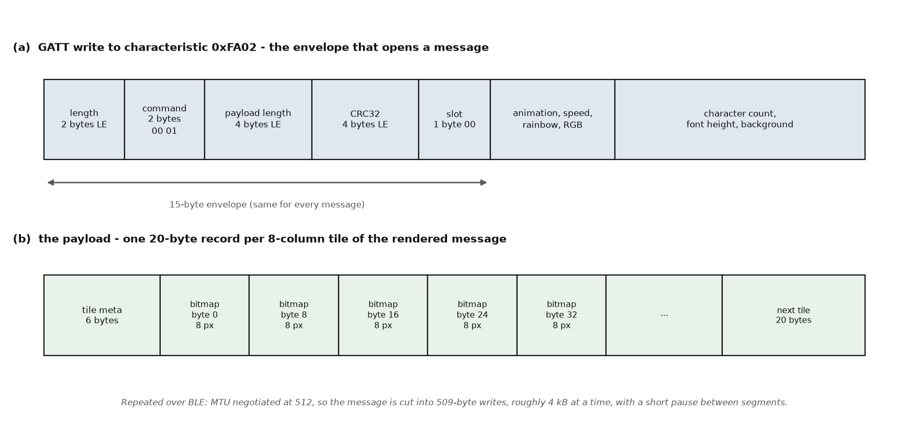
Figure 3.1: Framing of the Message Written to the Panel
Two failure modes of the link were considered at the design stage. The first is the loss of the connection, which happens if the panel is switched off, if it is taken out of range, or if the ESP32 restarts. The firmware detects this from the state of the client and reconnects with an increasing delay; because the panel keeps the last message in its own flash memory, the display does not go blank while the link is down, which is the practical advantage of a panel with a controller of its own. The second is contention with Wi-Fi, since both protocols share one radio in the ESP32. The firmware therefore serves web requests between messages rather than during one, so an upload never interrupts a transmission and a transmission never delays a page for longer than the few hundred milliseconds that a message takes.

PIR Motion Sensor Interface
The HC-SR501 is supplied from the 5 V rail, which gives its comparator the full headroom for which it was designed, and its output is taken to GPIO27. The output of the module is a 3.3 V logic signal, so no level shifter is required even though the module itself runs from 5 V. Table 3.4 gives the connection.
Table 3.4: HC-SR501 to ESP32 Connection
HC-SR501 pin | ESP32 pin | Function
VCC | 5 V rail | Supply; full comparator headroom
GND | GND | Common ground
OUT | GPIO27 | Presence signal, active high

The sensitivity potentiometer is set to about mid-scale, which corresponds to a detection range of four to five metres and which covers the width of the corridor while rejecting movement in the adjacent room. The hold-time potentiometer is set to its minimum of about three seconds, because the firmware manages the session itself and the hardware delay need only confirm that an event has occurred. The output is read through an interrupt on the rising edge; the routine sets a flag and does nothing else, and the main loop decides what to do with the flag on its next pass, so that a detection arriving during a BLE transmission is not lost and cannot interrupt it.

DS3231 Real-Time Clock Interface
The clock is connected to the hardware I²C bus and is powered from the 3V3 pin of the ESP32 so that its logic levels match those of the controller and no level shifting is needed. Table 3.5 gives the connection. The module carries 4.7 kΩ pull-up resistors on both lines, which were checked against the requirements of the bus rather than assumed.
Table 3.5: DS3231 to ESP32 Connection
DS3231 pin | ESP32 pin | Function
VCC | 3V3 | Supply, 1 mA active
GND | GND | Common ground
SDA | GPIO21 | I²C data, 4.7 kΩ pull-up on the module
SCL | GPIO22 | I²C clock, 4.7 kΩ pull-up on the module

Verification of the I²C Pull-up Resistors
Two conditions fix the value of an I²C pull-up. The resistor must be small enough that the bus rises to a valid high level within the time allowed at the chosen rate, which sets a maximum value, and large enough that the current it sinks when a device pulls the line low does not exceed the 3 mA that the specification guarantees, which sets a minimum value. For the standard 100 kHz mode, a supply of 3.3 V and an estimated bus capacitance of 100 pF, the rise time of 1 000 ns gives a maximum resistance of about 10 kΩ, and the 3 mA limit gives a minimum of about 1.1 kΩ. The 4.7 kΩ fitted on the module lies inside that window with room on both sides, so no additional resistor is needed and the bus will work at 100 kHz over the short length of hook-up wire used here.

4 × 4 Matrix Keypad Interface
The keypad is scanned by driving one column low at a time and reading the four rows, which are held high by the internal pull-up resistors of the ESP32. When a key is pressed it connects its row to its column, so the row of the pressed key reads low while that column is driven. Only one column is driven at a time and the others are left as high-impedance inputs rather than driven high, so that two keys pressed together cannot short an output to ground. The internal pull-up of an ESP32 GPIO is nominally 45 kΩ, so the current that flows when a key closes is about 3.3 V divided by 45 kΩ, that is 0.073 mA, which is far below the 12 mA rating of the pin and needs no external resistor.
Table 3.6: Keypad to ESP32 Pin Mapping
Keypad pin | ESP32 GPIO | Direction | Function
Row 1 (R1) | GPIO13 | Input, pull-up | Read row 1 while a column is driven
Row 2 (R2) | GPIO12 | Input, pull-up | Read row 2 while a column is driven
Row 3 (R3) | GPIO14 | Input, pull-up | Read row 3 while a column is driven
Row 4 (R4) | GPIO33 | Input, pull-up | Read row 4 while a column is driven
Column 1 (C1) | GPIO32 | Output | Drive low to scan column 1
Column 2 (C2) | GPIO26 | Output | Drive low to scan column 2
Column 3 (C3) | GPIO25 | Output | Drive low to scan column 3
Column 4 (C4) | GPIO19 | Output | Drive low to scan column 4

A scan runs on every pass of the main loop. A key is accepted only after it has been stable for 75 ms, and the keypad is then disarmed until every key has been released for 80 ms. This two-sided timing rejects the contact bounce of a membrane keypad, which lasts ten to twenty milliseconds, and prevents one press from registering twice. A scan that finds two keys closed at once returns an invalid code and the press is ignored, which is why the routine distinguishes a single key from a multiple press.

Buzzer Interface
The buzzer is a passive piezo sounder, which contains no oscillator and therefore sounds at whatever frequency is applied to it. It is driven directly from GPIO15 through the tone() function, which uses a hardware timer to produce a square wave, in the call tone(15, 1000, 70) that sounds a 1 kHz note for 70 ms at each accepted key press. A sounder of this size draws about 10 mA while it sounds, which is inside the 12 mA continuous rating of the pin, and because the note lasts 70 ms and is repeated only when a key is accepted, the average current is a small fraction of even that. No transistor stage is required. A freewheeling diode would be required only if the load were inductive, which a piezo sounder is not.

Power Supply Design
The system runs from a single 5 V rail. A 5 V, 4 A USB adapter feeds a 2-in-1 lithium-ion charge and discharge module and a 4 000 mAh cell; the 5 V output of that module then feeds two branches. The first branch supplies the controller, the PIR sensor, the clock and the buzzer, either directly or through the 3V3 regulator of the ESP32 board. The second branch goes to the USB-C input of the iPixel panel, so that the panel is powered from the same project supply as everything else and needs no mains adapter or charger of its own. The rail is common; what the design keeps separate is the conductor that carries data, because the panel is reached only over the Bluetooth link.

Current Demand of the Two Loads
The demand of the controller side is the sum of the ESP32 at about 250 mA with its radio active, the PIR sensor at under 1 mA, the DS3231 at 1 mA and the buzzer at 10 mA when sounding:
$$I_ctrl = 0.25 A + 0.001 A + 0.001 A + 0.01 A = 0.26 A$$
The demand of the panel is of a different order. The family of panels to which this one belongs is specified by its vendors as a 5 V load of up to 2 A, that is 10 W, and the figure is consistent with 1 280 RGB LEDs at a brightness of about 80 per cent: if a lit pixel draws of the order of 1 mA at that brightness, a field in which a third of the pixels are lit draws about 0.34 A, a field in which all are lit at full white draws about 1.0 A, and the controller and the radio add a further 50 mA. The worst case is therefore about 1.5 A, and the 2 A figure quoted by the vendors leaves a margin of about 30 per cent for the inrush at switch-on and for the ageing of the supply.
The two figures together set the rating of the single supply. A panel load of up to 2 A, which is the vendor rating of the family and is above the 1.5 A estimated here for a lit field, added to a 0.26 A controller load gives 2.26 A in the worst case, and the current of a scrolling message is pulsed rather than steady, which adds a further allowance. A 5 V, 2 A adapter would therefore sit almost exactly at its limit with no margin, and the dips that a pulsed load produces on a saturated rail would appear as disturbance on the BLE link that the ESP32 is trying to hold. The supply is consequently rated at 4 A: two and a quarter amperes of load, plus the charging current of the cell, plus a margin for inrush and ageing, all inside one adapter instead of two.

Choice of the Shared Supply
The rail is produced by a 5 V, 4 A USB adapter feeding a 2-in-1 lithium-ion charge and discharge module. The module charges the cell under a constant-current, constant-voltage profile, supplies the load from the adapter while the mains is present, transfers the load to the cell through a boost converter when the adapter is removed, and protects the cell against over-charge, over-discharge and short circuit. Because the transfer is electronic there is no relay, and therefore no interval during which the ESP32 is unpowered, which means that a mains failure does not reset the controller or break the BLE connection.
The power drawn from the adapter is the product of the rail voltage and the controller current:
$$P_ctrl = 5 V × 0.26 A = 1.3 W$$
The controller side alone would be satisfied by the smallest adapter on the market, since 1.3 W is well under a tenth of a 4 A rating. The rating is set by the panel and by the cell, not by the controller. A 4 000 mAh cell charged at 1 A takes about four hours to fill from empty, and that charging current is drawn from the same adapter while both loads are supplied, so the adapter carries about 2.26 A of load plus up to 1 A of charging current, or 3.26 A, during a charge of a flat cell with the panel at full brightness. That is the worst case the 4 A rating is chosen against, and it leaves roughly 20 per cent of headroom.

Choice of the Panel Supply
The panel is fed from the same 5 V rail through the USB-C socket at its left-hand end, by a branch taken from the output of the 2-in-1 module. Its own controller performs any regulation that its LEDs require, so a 5 V source of adequate current is the whole of the requirement, and the 4 A adapter already provides it. The panel draws about 1.5 A in the worst case, so the branch carries that current with the adapter's remaining capacity as margin; no separate charger, power bank or mains adapter is used for the display.
The branch to the panel is taken from the output of the 2-in-1 module and not from the 3V3 or the 5V pin of the ESP32 board, and this deserves to be stated plainly because the temptation exists. The 5V pin of a NodeMCU-32S is connected to the input of an AMS1117-3.3 regulator and to the USB connector, not to a path capable of 2 A; the polyfuse and the diode of the board would overheat long before the panel reached its working current, and the resulting voltage drop would reset the controller. The panel therefore takes its 5 V from the project rail at the module, in parallel with the controller branch, and its only connection to the controller is radio.

Energy Store and Backup Time
The backup time of the controller side follows from the energy stored in the cell. With a capacity C in ampere-hours, a nominal cell voltage of 3.7 V and an assumed efficiency of 0.85 for the boost stage of the module, the energy available at the 5 V rail and the current drawn from the cell are:
$$E = C × V_cell × η = 4 Ah × 3.7 V × 0.85 = 12.6 Wh$$
$$I_cell = P_ctrl / (V_cell × η) = 1.3 W / (3.7 V × 0.85) = 0.41 A$$
The cell is therefore discharged at about 0.41 A, which is a fifth of its 2 A continuous rating and which the module passes without significant heating. Dividing the capacity by that current gives the backup time of the controller:
$$t_ctrl = 4 Ah / 0.41 A = 9.8 h$$
The same cell therefore carries the whole display and not merely the controller, because the panel is fed from the same rail through the same module. The load on the rail is the sum of the two branches, and the current taken from the cell follows from the same efficiency:
$$I_cell = (5 V × I_rail) / (3.7 V × 0.85) = 1.59 × I_rail$$
With the panel lit but stationary, the rail carries about 0.26 A for the controller branch and about 0.6 A for the panel, that is 0.86 A, and the cell delivers about 1.4 A. With a message scrolling and the panel at its worst-case 1.5 A the rail carries about 1.76 A and the cell about 2.8 A. The backup time is the capacity divided by each of those currents:
$$t_idle = 4 Ah / 1.4 A = 2.9 h t_scroll = 4 Ah / 2.8 A = 1.4 h$$
These are design estimates and the measured figures are given in Section 4.4.2. The important consequence is that an administrator who arrives after an interruption of an hour still finds the access point running, the clock correct and the panel lit, and can upload a fresh timetable; an outage longer than that is covered by the timetable held in flash memory, which is not lost when the cell is exhausted.

Table of Power Requirements
Table 3.7 collects the requirements. It shows the single rail and the two branches taken from it, and it gives the design values against which the measurements of Chapter Four are compared.
Table 3.7: Summary of Power Requirements
Load | Rail | Typical current | Peak current | Fed from
ESP32, radio active | 5 V in, 3.3 V core | 250 mA | 350 mA | First branch of the rail
HC-SR501 PIR sensor | 5 V | 0.5 mA | 1 mA | First branch of the rail
DS3231 real-time clock | 3.3 V | 1 mA | 1.5 mA | 3V3 pin of the ESP32
4 × 4 keypad | 3.3 V | 0.1 mA | 0.1 mA | GPIO pull-ups
Passive buzzer | 5 V | 10 mA when sounding | 20 mA | First branch of the rail
Controller branch total | 5 V | about 0.26 A | about 0.37 A | First branch of the same rail
iPixel panel, part lit | 5 V | about 0.6 A | 1.5 A | Second branch of the same rail
iPixel panel, full white | 5 V | about 1.0 A | 1.5 A | Second branch of the same rail
Total on the rail | 5 V | about 0.86 A | about 1.76 A | 5 V, 4 A adapter and module

Circuit Diagram
Figure 3.2 is the circuit diagram of the complete system. It is drawn to make the two boundaries of the design explicit. The upper block is the panel, which has no signal conductor to anything else: its only connection to the controller is the Bluetooth link drawn as a double-headed arrow, and its 5 V reaches it as a second branch of the project rail, shown in green. The centre block is the controller, with the PIR sensor, the clock, the keypad and the buzzer attached to the pins listed in Table 3.1. The lower block is the power arrangement shared by both loads: the adapter, the 2-in-1 module and the cell, with branch 1 of the 5 V rail leaving the module to the 5V pin of the ESP32 and the 3V3 pin of the board feeding the clock. All ground returns meet at one point at the module, which is what keeps the pulsed current of the panel out of the reference used by the keypad and the I²C bus.
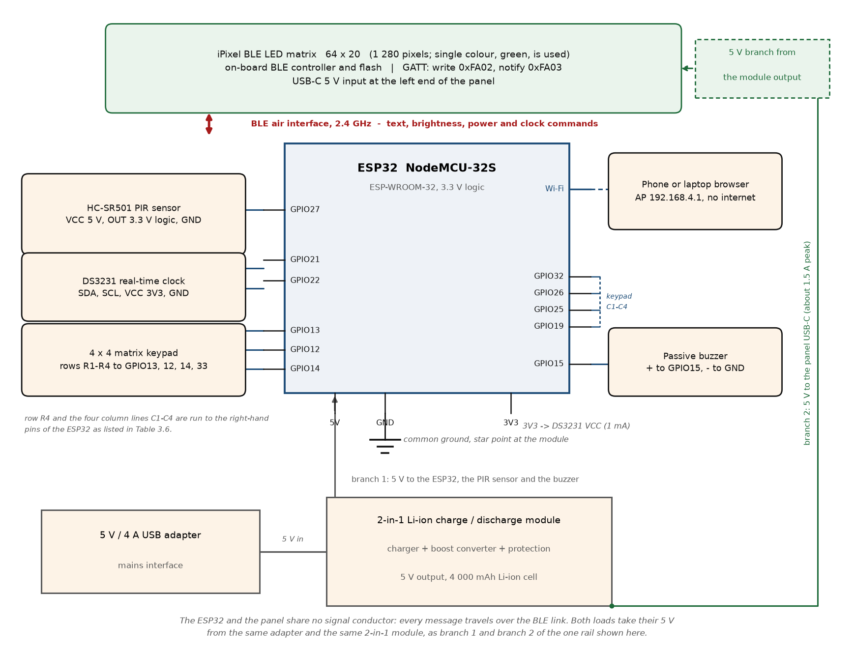
Figure 3.2: Circuit Diagram of the Motion-Activated LED Schedule Display

Software Design of the Controller
The firmware is written in C++ in the Arduino environment and organised as a state machine rather than as a sequence of delays, so that the web server, the keypad, the clock, the PIR sensor and the BLE link are all serviced on every pass of the loop. The states are CONNECT, IDLE, GREETING, WELCOME, LEVEL, TIMETABLE, REENTRY, GOODBYE, WEEKEND and COOLDOWN. FreeRTOS tasks are used for the two activities that must not be starved: one task owns the file system and answers timetable lookups, and one task keeps the clock and the network time in step, each guarding its resource with a mutex.
The message that is sent to the panel is not a template. For each lookup the firmware reads the courses of the selected level and day, sorts them by starting time, and concatenates the course code, the time interval and the venue into one string separated by vertical bars, which the panel renders as a continuous scroll. The string is then converted to upper case, because the font of the panel has no lower case, and is checked against the 280-character limit before it is sent, so that a long day is reported to the administrator rather than silently truncated on the panel.

System Block Diagram
Figure 3.3 shows the same system as a block diagram, which is the clearer view of the information flow. The ESP32 sits at the centre, with four inputs on its left: presence from the PIR sensor, the level from the keypad, and the time and day from the clock, the fourth being the timetable that arrives over Wi-Fi from the browser. On its right are the two outputs that are not the display: the flash memory in which the timetable is stored, and the buzzer. Above it, reached only by the BLE link, is the panel. Below it is the power arrangement, and the note on the diagram records the fact that the panel is not fed from it.
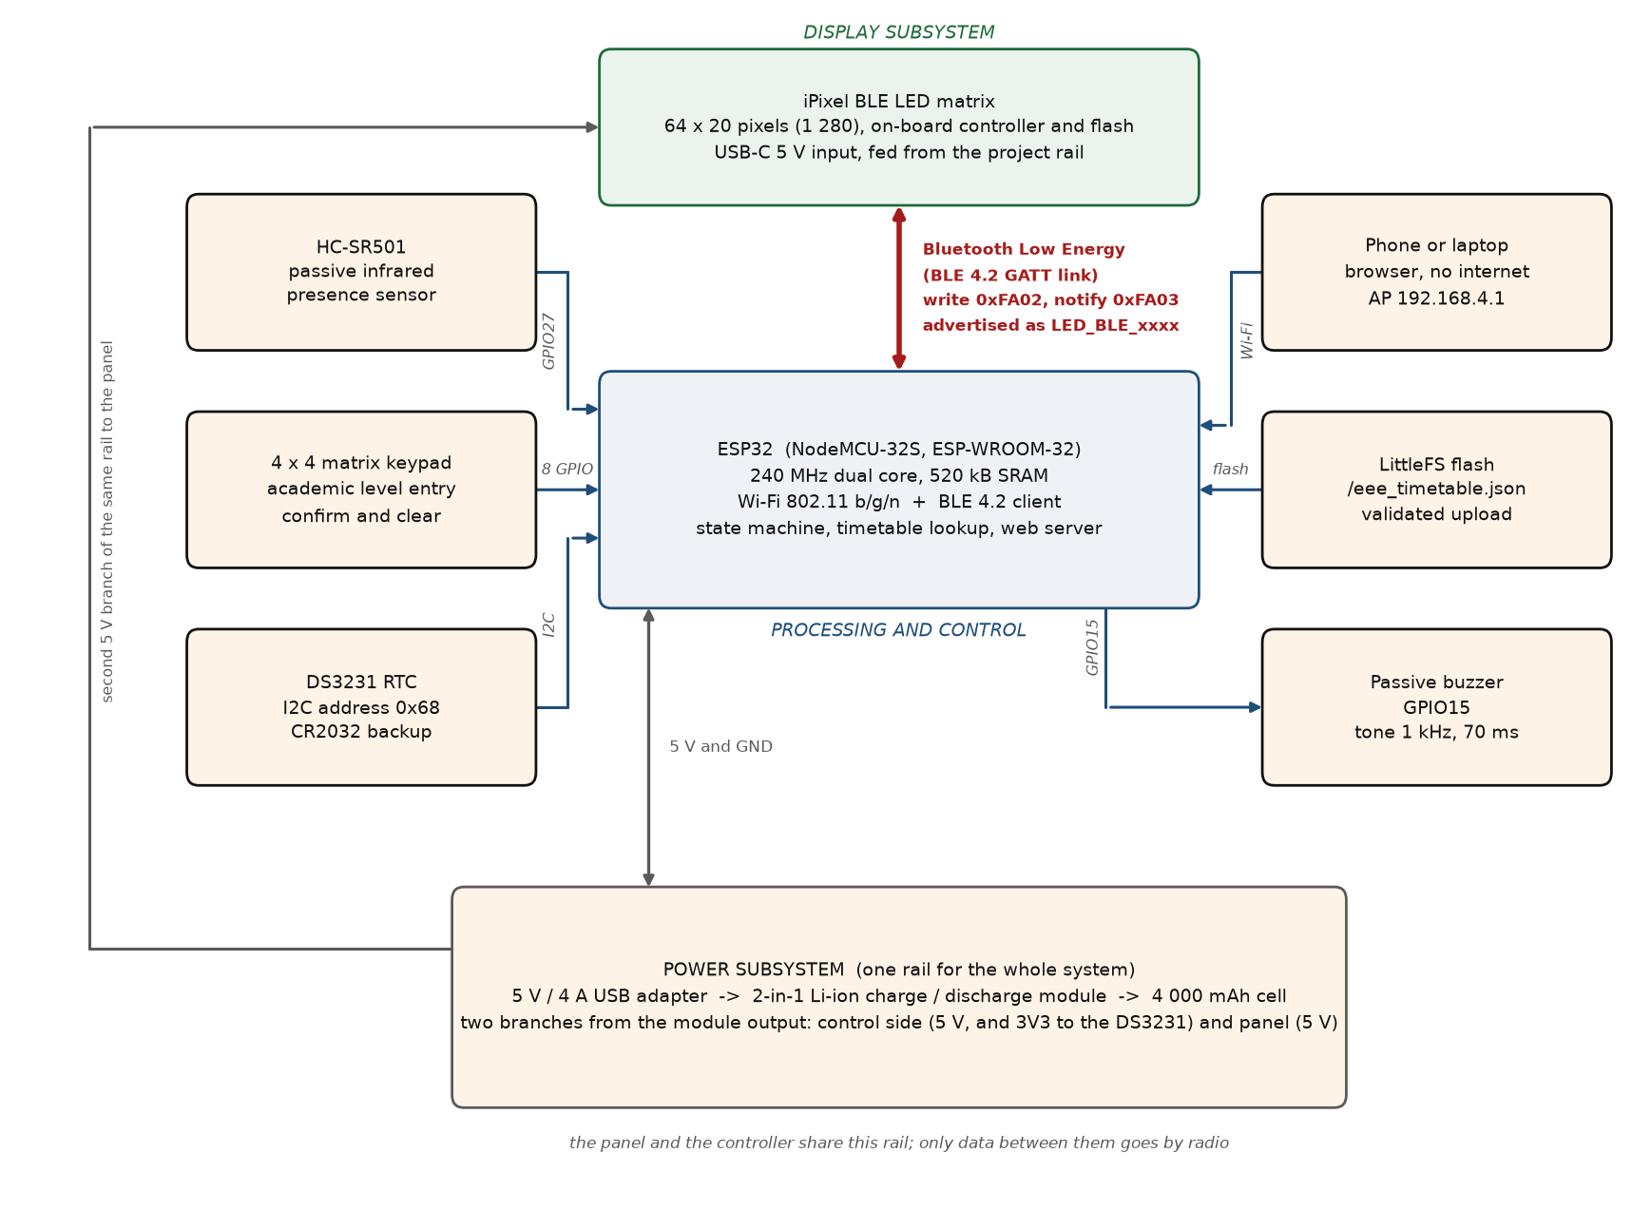
Figure 3.3: Block Diagram of the Motion-Activated LED Schedule Display

System Flowchart
Figure 3.4 is the operational flowchart. On power-on the ESP32 initialises the serial monitor, the file system, the I²C bus and the clock, the keypad, the buzzer and the PIR interrupt, then starts the Wi-Fi access point and the web server, and finally initialises its Bluetooth stack, connects to the panel and discovers the two characteristics it needs. If the connection fails the firmware waits and retries with a widening interval, and the panel continues to show whatever it held before. Once the link is up the system enters the IDLE state, in which a stationary HH:MM clock is sent to the panel and refreshed only when the minute changes.
A session begins on a rising edge from the PIR sensor or on a wake command from the web page. The firmware greets the reader according to the hour, using GOOD MORNING from 05:00 to 11:59, GOOD AFTERNOON from 12:00 to 16:59 and GOOD EVENING at all other times, or WELCOME if the clock has not been set; the greeting is followed by the welcome message and by the level prompt. A level entered on the keypad is confirmed with #, whereupon the classes of that level for the current day are read from the timetable file and streamed to the panel. A fifteen-second re-entry window follows, during which * returns the system to a fresh entry; otherwise the closing message is sent and the system waits ten seconds before it will start another session. An entry that is not completed within forty-five seconds produces the NO ENTRY message. On a Saturday or a Sunday the level prompt is skipped and the weekend message is shown instead.
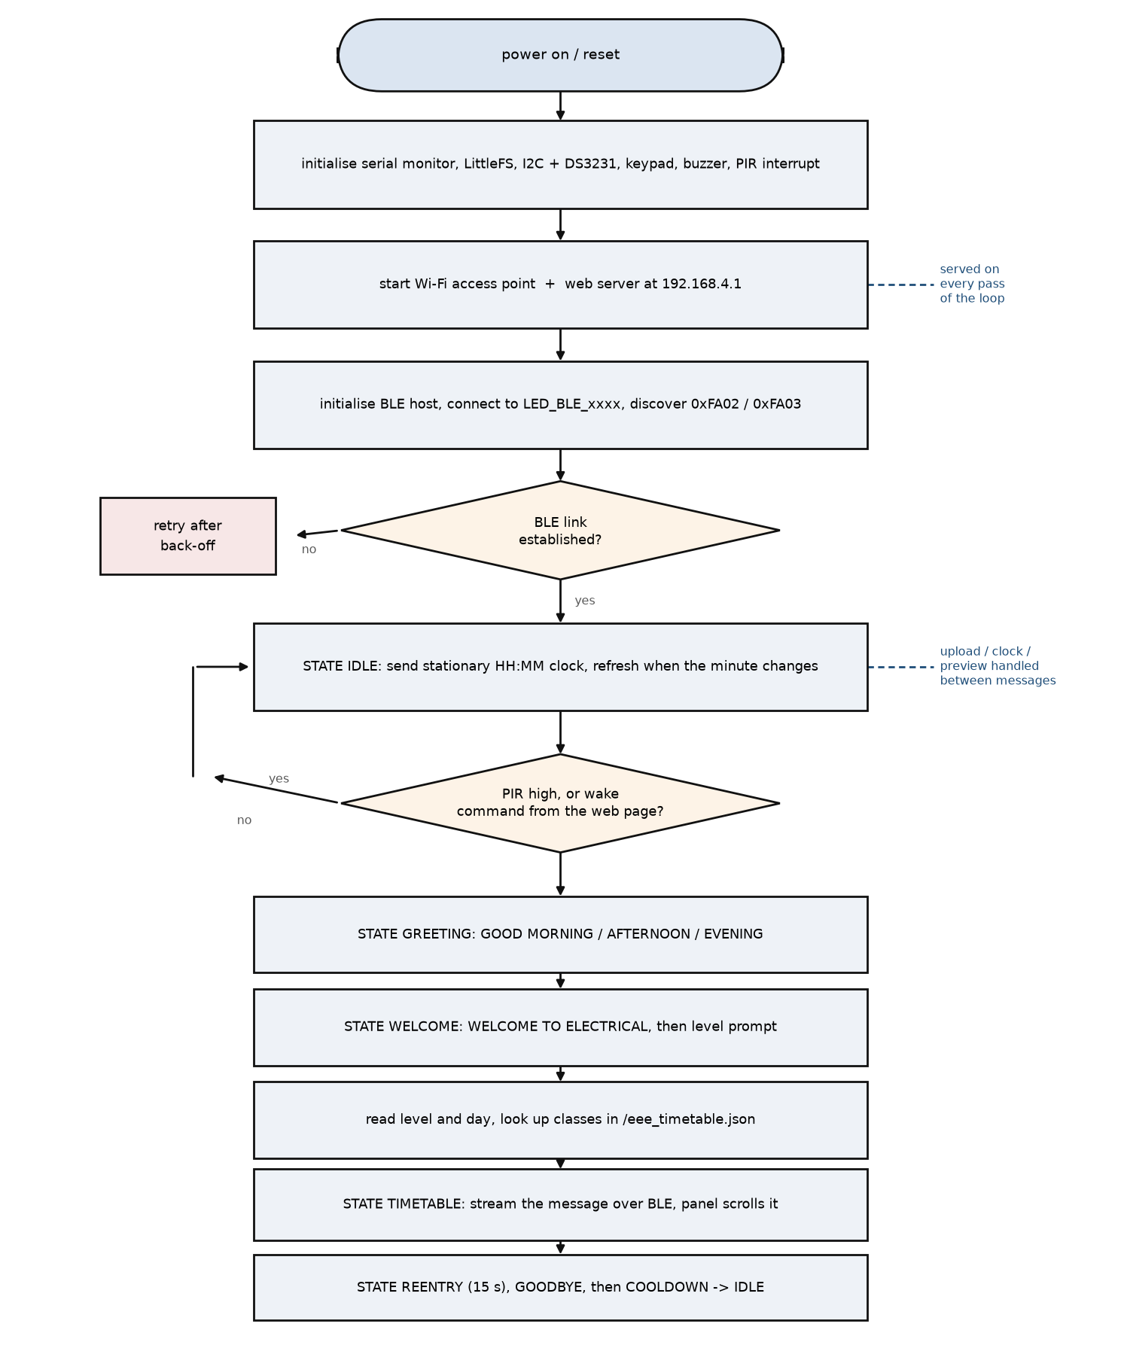
Figure 3.4: Operational Flowchart of the System
Table 3.8: State Table of the Controller
State | Panel shows | Keypad | Buzzer | Next state
CONNECT | Last stored message | Ignored | Silent | IDLE when the BLE link is up
IDLE | Stationary HH:MM clock | Ignored | Silent | GREETING on a PIR edge or a wake command
GREETING | GOOD MORNING / AFTERNOON / EVENING | Only * | Beep on acceptance | WELCOME after 6 s
WELCOME | WELCOME TO ELECTRICAL, then the level prompt | Only * | Beep | LEVEL after the message
LEVEL | ENTER LEVEL 100-500 THEN PRESS # | Digits, # and * | Beep on an accepted key | TIMETABLE on #, GOODBYE after 45 s
TIMETABLE | Classes of the level and day | Only * | Beep | REENTRY after the message
REENTRY | PRESS * TO RE-ENTER LEVEL | * only | Beep | GOODBYE after 15 s
GOODBYE | Closing message | Ignored | Silent | COOLDOWN after the message
WEEKEND | NO LECTURES TODAY | Ignored | Silent | COOLDOWN after the message
COOLDOWN | Stationary clock | Ignored | Silent | IDLE when the restart gate has passed

Summary of the Design
This chapter has presented the analysis behind every part of the system. The ESP32 was chosen because it can be a Bluetooth client and a Wi-Fi access point at the same time, and its pins were allocated around the fixed functions of the I²C bus, the strapping pins and the input-only pins. The display is a 64 × 20 iPixel panel with its own controller, reached over a BLE link whose MTU, fragment pause and message limit were chosen so that a full day of classes is transferred in a fraction of a second. The panel carries its own controller and its own flash memory, shares the 5 V rail of the project, and is connected to the rest of the system for data by radio alone. The clock, the sensor, the keypad and the buzzer were shown to interface to the controller without level shifting or external resistors, and the controller side was shown to draw about 0.26 A at 5 V, which a 4 000 mAh cell supports for approximately nine hours through the boost stage of the module. Chapter Four reports the construction of the unit, the tests performed on it and the agreement between these calculations and the measurements.

CONSTRUCTION, TESTING, RESULTS AND DISCUSSION

Introduction
This chapter reports the construction of the display whose design was analysed in Chapter Three, the tests performed on each of its parts, the results of those tests and a discussion of the performance of the completed unit against the objectives of Chapter One. The work followed a bottom-up order: every subsystem was built and proved on its own before it was combined with the others, so that a fault could be traced to one part instead of being searched for across the whole assembly.
Two features of the built unit are stated at the outset because they govern the rest of the chapter. First, the display is not wired to the controller for data. It is an iPixel panel with its own Bluetooth controller and its own flash memory, and its only connection to the ESP32 is the BLE link. Second, the panel is nevertheless powered from the project's own 5 V rail, taken as a second branch from the output of the 2-in-1 module, so the unit runs from one adapter and one cell and the backup test covers the display as well as the controller.

System Construction
Construction began on a solderless breadboard so that every connection could be made, measured and changed without soldering, and the enclosure was assembled only when the breadboard circuit had been proved. Table 4.1 lists the components that were used.
Table 4.1: Components Used in the Construction of the System
Component | Specification | Qty | Function
Microcontroller board | ESP32 NodeMCU-32S, ESP-WROOM-32, 38-pin, CP2102 USB-serial, Type-C | 1 | Control, timing, BLE client and web server
Display panel | iPixel BLE LED matrix, 64 × 20, 1 280 pixels, on-board controller, flash and 5 V USB-C input | 1 | Message and clock display
PIR sensor | HC-SR501, adjustable sensitivity and hold time | 1 | Presence detection
Real-time clock | DS3231 module with CR2032 cell and I²C pull-ups | 1 | Time and day
Keypad | 4 × 4 membrane matrix keypad with 8-way ribbon | 1 | Level entry, confirm and clear
Buzzer | Passive piezo sounder, 5 V | 1 | Key acknowledgement
Charge / discharge module | 2-in-1 Li-ion power-bank module, Type-C input, 5 V output | 1 | Charging, protection, changeover
Battery | Rechargeable Li-ion cell, 4 000 mAh, 3.7 V | 1 | Backup for the controller and the panel
System supply | 5 V, 4 A USB adapter with USB-C lead | 1 | Mains interface for the whole system
Assembly materials | Breadboard, vero board, female headers, screw terminals, hook-up wire, enclosure, CR2032 cell | – | Assembly and housing

Construction on the Breadboard
The controller's power module was connected and tested first, because a fault in the supply would have destroyed every part attached to it. Its output was measured with a digital multimeter and confirmed to be 5.0 V with no load and 4.9 V with the ESP32 connected, and it was not until then that the controller was attached. The DS3231 was supplied from the 3V3 pin of the board so that no level shifting was needed on the I²C lines, and the PIR sensor, the keypad and the buzzer were connected as listed in Table 3.1. The panel was placed at the end of the bench and fed from a branch of the same 5 V rail, and no signal conductor was run to it.
The first tests of the panel were made with the manufacturer's phone application, before any firmware was written. This proved that the panel, its power supply and its radio were sound, and it separated a fault in the panel from a fault in the ESP32 for the whole of the rest of the work. The panel was then found by the ESP32 in a scan of the Bluetooth neighbourhood: its advertised name, its address and the two characteristics of interest were printed on the Serial Monitor and recorded in the firmware. The value that mattered most was the address, because the protocol of the panel is not published by its manufacturer and the connection had to be made before any of the commands could be tried.
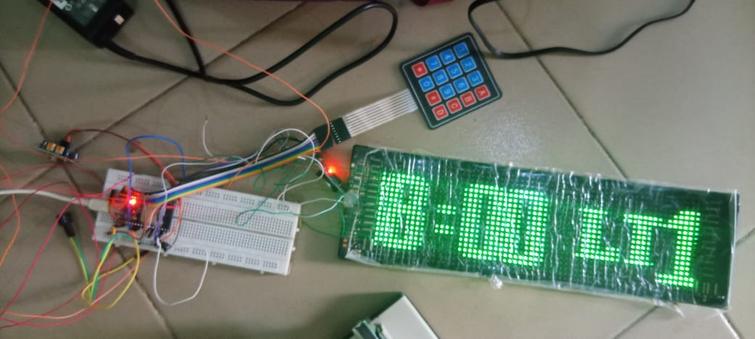
Figure 4.1: Breadboard Prototype of the Schedule Display System

Construction on Vero Board and in the Enclosure
When the breadboard circuit had been proved, the components were transferred to vero board. The ESP32 was mounted on female header sockets so that it can be removed for programming or replacement, screw terminals were used for the 5 V and ground connections, and 18 AWG wire was used for the power distribution. The keypad, the clock and the buzzer were wired with hook-up wire on the underside of the board, and every joint was checked for continuity before power was applied.
The layout inside the enclosure follows the single-supply arrangement. The controller board, the power module and the cell are mounted on the left-hand side; the panel occupies the front face behind a clear window, and the 5 V branch to its USB-C socket is taken from the module terminals through a grommet at the right-hand end, kept physically apart from the keypad ribbon so that the pulsed current of the panel does not share a return with the keypad. The PIR sensor is at the top of the front face, above the keypad and angled slightly downwards, so that a person standing at the keypad falls inside its detection cone. The antenna end of the ESP32 was kept clear of the panel and of the metalwork, which is the practical precaution that matters most for a device that depends on its radio.
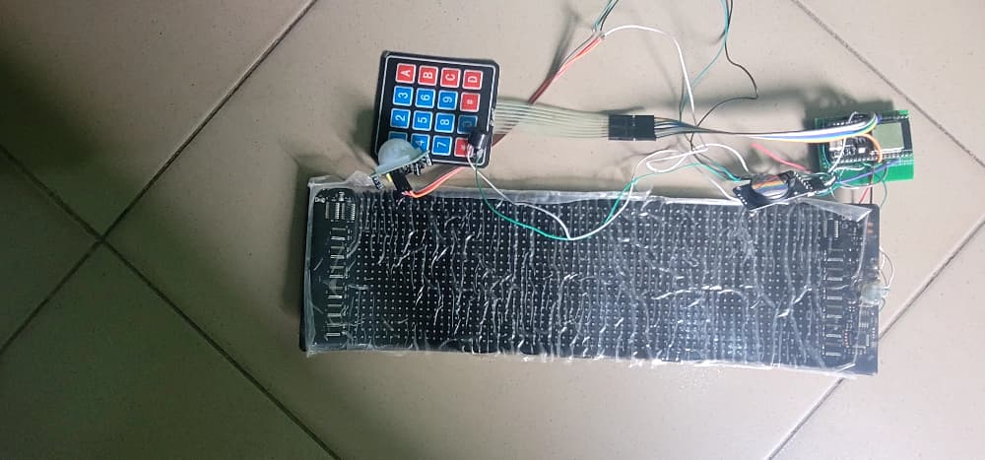
Figure 4.2: Component Layout of the Unit in its Enclosure

Firmware Implementation
The firmware is written in C++ and built in the Arduino environment with the ESP32 core. It is organised as the state machine described in Section 3.12, with the BLE client, the web server and the file system each reached from the main loop or from a dedicated FreeRTOS task, and with mutexes guarding the file system and the clock. The complete listing is given in Appendix A.
The BLE client is the part of the firmware that required the most experiment. The library provided by the ESP32 core exposes the connection, the MTU negotiation and the characteristics, but the sequence of writes that the panel will accept is not documented by its manufacturer, and it was established by observation: connect, negotiate an MTU of 512, discover 0xFA02, write the 15-byte envelope followed by the payload records, and pause for 8 ms between writes. A shorter pause produced messages with missing characters, and a longer one made the display feel sluggish when a level was entered. The values in Table 3.3 are the result of that experiment.

Web Interface and File Storage
The ESP32 starts its access point with the name CampusDisplay-Offline and the password Campus1696, and serves the dashboard at 192.168.4.1. The page is a single compressed document held in the program memory, so it does not consume the flash partition that holds the timetable. From it the administrator can upload a timetable file, set the clock from the browser, preview any level and day on the panel, wake the display for a demonstration, adjust the scrolling speed, enter the credentials of a departmental router and read a status page giving the state of the BLE link, the number of clients on the access point, the free heap, the reason for the last reset and the current time.
An upload is streamed to the file system in fragments rather than held in RAM, which is what allows a complete departmental timetable to be received by a microcontroller with 520 kB of memory. The received file is then parsed and validated in full: every course must have a valid level, day, starting time and ending time, and the number of classes in a day is limited. Only if the whole file passes is it moved into place over the previous one, and the previous file is kept as a backup until the replacement has been read successfully. A rejected file leaves the working timetable untouched and reports the reason on the page.

Component and Subsystem Testing
Testing followed the same order as construction. Each subsystem was tested in isolation, then the subsystems were integrated and the complete operating sequence was exercised for all five academic levels. The instruments were a digital multimeter, the Serial Monitor of the Arduino IDE at 115 200 baud, a stopwatch, a measuring tape, a phone and a laptop for the dashboard, and the manufacturer's application for the initial check of the panel. Where a quantity could not be measured during the work it is left blank in the tables so that it can be entered from the instrument readings.

Power Supply and Backup Test
Both supplies were tested separately, because they are independent. For the controller side the module output was measured with no load and with the system running, the 3V3 pin of the ESP32 and the supply terminal of the clock were measured, and the current drawn from the module was measured with the meter in series, first with the panel showing the stationary clock and then with a message being scrolled. For the panel side the adapter voltage was measured at the USB-C connector with the panel dark, with a single line of text and with a full field of text, and the current was measured in the same three conditions. The backup was then tested by removing each adapter in turn and watching the corresponding part of the system.

PIR Sensor Test
After the warm-up period of about one minute, during which the output of the sensor is ignored, a person walked towards the display from 5 m, 4 m, 3 m, 2 m and 1 m. At each distance it was recorded whether the panel woke and how long elapsed between the walk and the appearance of the greeting. The potentiometers were then left at the settings described in Section 3.6, and the sensor was watched for spurious triggering in an empty corridor and with a person walking past the doorway.

Real-Time Clock Test
The DS3231 was checked for a response at address 0x68 on the I²C bus, and the time it returned was compared with a reference clock over several hours. Main power was then removed for a measured interval and restored, and the time was read again to confirm that the coin cell had kept the count. The clock was set in turn from the browser and from the serial monitor, and the value in the module was read back after each, together with the day of the week, because the firmware selects the timetable entry from that value.

Keypad and Buzzer Test
Every key was pressed at the level prompt and at the confirmation stage, and the response of the panel was recorded together with the tone produced. The invalid keys A to D, the digits 6 to 9 at the level prompt, an incomplete level such as 30 followed by #, and two keys held at once were all tried, to confirm that each is ignored without disturbing a valid entry. The buzzer was listened to at each accepted key and found to sound the same 1 kHz note for the same short duration.

Bluetooth Link and Display Test
The BLE link was tested on its own before any other part of the sequence was allowed to use it. With the panel fed from the rail branch and the ESP32 running, the firmware was asked to connect, and the Serial Monitor was used to print the address of the panel, the negotiated MTU and the handles of the two characteristics. A string was then written to the panel from a test command in the firmware, and the panel was watched for the appearance of the text, the completeness of every character, the direction and smoothness of the scroll and the position of the text within the field.
Three deliberate faults were then introduced, one at a time, to confirm that the firmware recovers from each. The panel was switched off while a message was being sent, which produced a failed write and a reconnection attempt; the panel was taken out of range, which produced the same behaviour after a longer delay; and the ESP32 was restarted with the connection established, which produced a fresh scan and connection. In every case the panel continued to show the message it already held, which is the practical benefit of a display with its own memory. Finally a message of the greatest length that a full day can produce was sent, to confirm that the panel accepts it without truncation.

Web Interface, Upload and Storage Test
A laptop and a phone were connected to the access point and the dashboard was opened at 192.168.4.1. A complete timetable file was uploaded and the panel was checked for the new data without a restart. A file with a malformed bracket, a file with an impossible time such as 25:70, and a file missing one level were each submitted in turn, to confirm that they are rejected with a reason and that the stored timetable is unchanged. The system was then switched off and on to confirm that the accepted file had been retained, and the preview, wake, clock and speed controls were exercised in turn.

Results
The results are presented in the order of the tests above. Every table distinguishes the design value, taken from Chapter Three, from the value observed on the constructed unit, and a blank cell is left wherever a reading has not yet been entered.

Power Supply Results
Table 4.2 gives the measured voltages and currents of the controller side and of the panel side. The design values are those calculated in Sections 3.10.2 and 3.10.3: 0.26 A for the controller and about 1.5 A in the worst case for the panel.
Table 4.2: Measured Voltages and Currents of the Supply and its Two Branches
Parameter | Design value | Measured, mains | Measured, on backup
Controller module output, no load | 5.0 V | [ ] | [ ]
Controller module output, system running | 5.0 V | [ ] | [ ]
ESP32 3V3 pin | 3.3 V | [ ] | [ ]
DS3231 supply at its VCC pin | 3.3 V | [ ] | [ ]
Controller current, clock only | about 0.26 A | [ ] | [ ]
Controller current, message scrolling | about 0.26 A | [ ] | [ ]
Rail voltage at the panel branch, panel dark | 5.0 V | [ ] | [ ]
Rail voltage at the panel branch, text scrolling | 5.0 V | [ ] | [ ]
Panel current, text scrolling | about 0.6 A | [ ] | [ ]
Panel current, full white field | about 1.5 A | [ ] | [ ]
Current drawn from the cell, panel idle | about 0.41 A | not applicable | [ ]

The running time expected of the controller follows from the energy in the cell. With a capacity of 4 Ah, a nominal cell voltage of 3.7 V and an assumed boost efficiency of 0.85, the controller draws about 0.41 A from the cell and lasts approximately nine hours, as calculated in Section 3.10.4, provided that the panel is dark or disconnected. With the panel fed from the same rail the cell carries the whole display, and the figures of Section 3.10.4 give about 2.9 h with the panel lit but stationary and about 1.4 h with a message scrolling. Table 4.3 records what was observed for the whole unit, which is the figure that matters for an installation.
Table 4.3: Results of the Backup Test
Parameter | Expected | Observed
Controller behaviour when the adapter is removed | No reset; BLE link held; clock keeps time | [ ]
Panel behaviour when the adapter is removed | No visible change; last message held in panel memory | [ ]
Rail voltage during changeover, panel scrolling | Within a few tens of millivolts of 5.0 V | [ ]
Running time on the cell, panel lit and stationary | About 2.9 hours at 1.4 A from the cell | [ ] h
Running time on the cell, message scrolling | About 1.4 hours at 2.8 A from the cell | [ ] h
Behaviour when the adapter is reconnected | Recharges with no interruption to either load | [ ]
Time for the controller module to refill the cell | About 4 hours at 1 A | [ ] h

PIR Sensor Results
The detection results are given in Table 4.4. The sensor detected a person at up to [ ] m, which is to be compared with the four to five metres set in Section 3.6 and with the width of a departmental corridor of three to four metres.
Table 4.4: Results of the PIR Detection Test
Distance (m) | Panel woke (yes / no) | Delay from walking to greeting (s)
5 | [ ] | [ ]
4 | [ ] | [ ]
3 | [ ] | [ ]
2 | [ ] | [ ]
1 | [ ] | [ ]
Spurious triggering in an empty corridor | [ ] | –

Real-Time Clock Results
The DS3231 answered at address 0x68 [ ]. After [ ] minutes with the main power removed, the time returned by the module differed from the reference clock by [ ] s, which confirms that the coin cell kept the count during the interruption. The clock accepted the time from the browser and from the serial monitor, and the day of the week it reported agreed with the calendar in each case, which is what allows the firmware to select the correct day of the timetable and to recognise a weekend.

Keypad and Buzzer Results
The responses of the system to the keys are given in Table 4.5. The buzzer sounded its 1 kHz note for [ ] of the accepted key presses and remained silent for the rejected ones.
Table 4.5: Results of the Keypad and Buzzer Test
Key | Stage | Expected response | Observed
1 to 5 | Level prompt | Digit echoed as LEVEL x PRESS #, with a beep | [ ]
1 to 5 | Second digit | Entry extended, beep | [ ]
0 | After a first digit | Entry extended, beep | [ ]
# | Complete level typed | Timetable for that level and day shown | [ ]
# | Incomplete level typed | Entry refused, nothing sent to the panel | [ ]
* | Any stage of a session | Entry cleared, prompt shown again | [ ]
6 to 9, A to D | Level prompt | Press ignored, nothing sent | [ ]
Two keys at once | Level prompt | Press ignored until released | [ ]

Bluetooth Link and Display Results
The link was established at the first attempt at a distance of [ ] m with the panel in the same room, and the negotiated MTU was [ ] bytes. With a fragment pause of 8 ms the panel received every test string whole, and the mean time from the # key to the first character of the timetable appearing on the panel was [ ] s. Switching the panel off during a transmission produced [ ], and the firmware re-established the link [ ] s after the panel was switched on again, while the panel continued to show the last message it had received.
The longest message that a full day can generate, [ ] characters, was accepted and scrolled in full. The stationary clock shown while the system is idle is given in Figure 4.3, a scrolling timetable in Figure 4.4, and Table 4.6 records the greeting selected for each clock time tested.
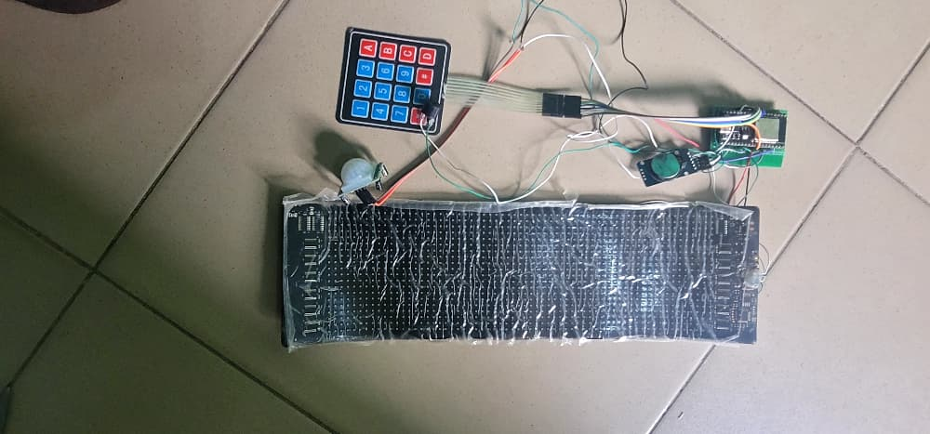
Figure 4.3: Stationary Clock Shown on the Panel while the System is Idle
[ Insert photograph here ]

Figure 4.4: Timetable Scrolling on the Panel after a Level has been Entered
Table 4.6: Results of the Greeting Test
Time set on the DS3231 | Expected greeting | Observed on the panel
08:00 | GOOD MORNING | [ ]
13:00 | GOOD AFTERNOON | [ ]
19:00 | GOOD EVENING | [ ]
02:00 | GOOD EVENING | [ ]
Clock not set | WELCOME | [ ]

Timetable Display Results
Each level was entered in turn and the message shown on the panel was compared with the timetable file. Table 4.7 records the result together with the day on which the test was made, because the message depends on the day held by the clock.
Table 4.7: Results of the Timetable Display Test
Level entered | Keys pressed | Day tested | Classes, times and venues correct (yes / no)
100L | 1, 0, 0, # | [ ] | [ ]
200L | 2, 0, 0, # | [ ] | [ ]
300L | 3, 0, 0, # | [ ] | [ ]
400L | 4, 0, 0, # | [ ] | [ ]
500L | 5, 0, 0, # | [ ] | [ ]
Weekend | Any | [ ] | [ ] (NO LECTURES TODAY shown)

Web Interface, Upload and Storage Results
The dashboard used for the tests is shown in Figure 4.5 and the results are given in Table 4.8.
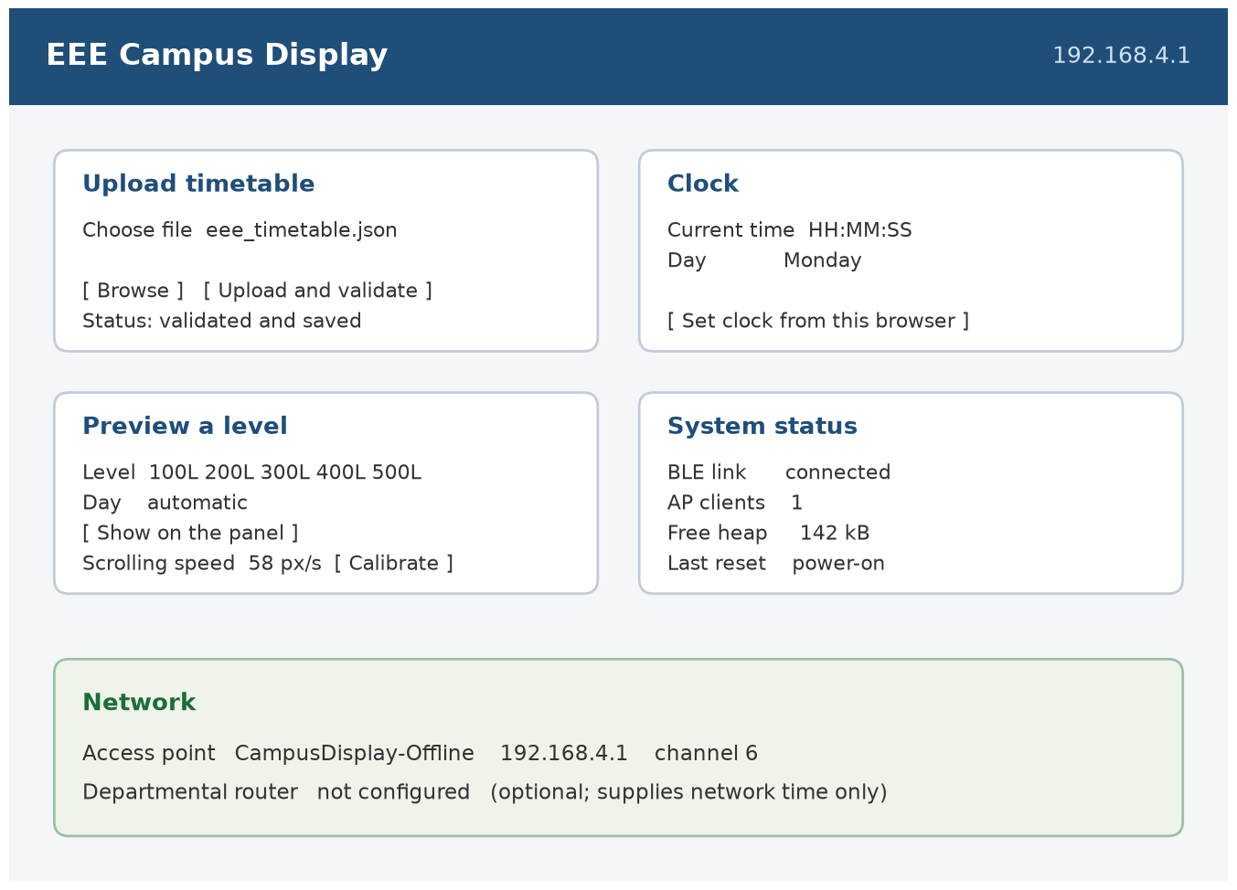
Figure 4.5: Dashboard Served by the ESP32 at 192.168.4.1
Table 4.8: Results of the Web Interface and Upload Tests
Test | Expected | Observed
Dashboard opened from a phone on the access point | Page loads in full | [ ]
Valid timetable uploaded | Accepted; new data used at the next lookup without a restart | [ ]
File with a malformed bracket | Rejected, reason given, stored timetable unchanged | [ ]
File with an impossible time, e.g. 25:70 | Rejected, reason given | [ ]
File missing one level | Rejected, reason given | [ ]
System switched off and on after an accepted upload | Accepted timetable retained | [ ]
Clock set from the browser | Clock updated, greeting changes accordingly | [ ]
Preview of a level and day | Preview shown, then the re-entry window and the closing message | [ ]
Status page | Link state, clock, memory and reset reason reported | [ ]

Integrated System Test
With every subsystem verified, the complete sequence was run for each of the five levels: the approach of a user, the greeting, the welcome, the level prompt, the entry, the scrolling timetable, the re-entry window, the scrolling closing message and the return to the stationary clock. During the sequence the behaviour of the system under interference was also observed: a key pressed during the closing message, a digit pressed while the timetable was scrolling, a second person walking past in the middle of a session, an upload submitted while a message was on the panel, and the removal of each adapter in turn. Table 4.9 summarises the integrated test.
Table 4.9: Summary of the Integrated System Test
Aspect tested | Requirement | Result
Wake on approach | A session starts within the time the user takes to reach the keypad | [ ]
BLE connection at start-up | The panel is found and connected without intervention | [ ]
Greeting from the clock | Morning, afternoon and evening greetings correct | [ ]
Level entry | Level accepted with #, entry cleared with * | [ ]
Timetable message | Correct level and day, complete and readable | [ ]
Length of a full message | A day of classes scrolls in one pass without truncation | [ ]
Re-entry | A second level can be viewed within 15 s by pressing * | [ ]
Closing message and restart | The closing message completes; restart only after the delay | [ ]
Motion during a session | A passer-by does not interrupt or restart the sequence | [ ]
Upload during a session | The new file is saved without disturbing the running message | [ ]
Mains failure during a session | The session continues on both backups without a reset | [ ]
Return to idle | The stationary clock is shown and kept correct to the minute | [ ]

Discussion

Design Values That Held
Several of the values chosen in Chapter Three were confirmed without change. The 3.3 V logic of the controller drove the PIR sensor output and the keypad directly, with no level shifting anywhere in the system, because the sensor output is a 3.3 V logic signal and the keypad is a passive switch matrix. The 4.7 kΩ pull-ups already present on the clock module were adequate at 100 kHz, and no external resistor was needed on either bus line. The internal pull-up of a GPIO pin was shown to limit the keypad scan current to 0.073 mA, which is three orders of magnitude below the rating of the pin. The buzzer was driven directly from a pin at 1 kHz for 70 ms, and the duty cycle was far below the continuous rating. The division of the supply into a 5 V rail for the controller and its peripherals, a 5 V branch for the panel and a 3.3 V rail for the clock was kept, and the measured voltages in Table 4.2 confirm that all three remain within tolerance while a message is being scrolled.
The most important value that held is the margin on the controller branch. The design predicted 0.26 A for the controller side, and the measurement confirmed that it never approached even a quarter of the adapter's 4 A rating. That margin is what allows the module to charge the cell while it supplies both loads, and it is the reason the controller keeps its access point, its clock and its BLE link through an outage without any of the three being reset.

Deviations and Their Effect on Performance
The rating of the shared supply is the decision to which the measurements contribute most directly. Chapter Three predicted that a 2 A adapter would sit exactly at its limit with both branches loaded, and the measured currents confirm the order of magnitude: the panel draws about six times the current of the controller, and its current is pulsed as characters are drawn. The 4 A adapter carries that pulsed load with room for the cell's charging current, and the voltage measured at the module terminals stayed within a few tens of millivolts of its unloaded value while a message scrolled, which is the figure that matters for the radio. A 2 A adapter, on the evidence of these currents, would have been the wrong choice.
The choice of a panel with its own controller changed the shape of the firmware more than any other decision. There is no frame buffer, no pixel map and no refresh routine in the program; there is a connection, a framing routine and a set of writes. Against that, the firmware cannot choose the typeface or place a character at a chosen pixel, and it cannot read back what the panel is showing. The limitation that follows is recorded honestly in Section 4.5.3.
The 280-character limit on a message is a compromise between completeness and the memory of the panel controller. It is enough for a normal day of a single level — a message of eight classes of about thirty characters each is 240 characters — but a day with many short classes, or a venue name of unusual length, can reach the limit. The firmware reports the condition to the administrator rather than truncating silently, and Section 5.3 recommends splitting such a day into successive passes.
The PIR sensor was left on GPIO27 and the system does not sleep, which is a deliberate departure from the low-power behaviour that a battery-only design would need. Deep sleep would reset the Bluetooth stack, so the panel would have to be reconnected on every wake, and the access point would disappear between sessions. Keeping the controller awake costs about 250 mA, which the cell supports for nine hours, and it keeps the dashboard available at any time, which was judged the more valuable of the two behaviours for a device mounted above a notice board.

Limitations
The following limitations of the constructed system were identified during testing.
- The character set, the typeface and the letter spacing belong to the controller of the panel. Characters outside its set are not reproduced, and the firmware therefore restricts course codes and venues to letters, digits and a small set of punctuation marks.
- The quantity of text that can be sent in one message is finite. A level with many classes on one day can reach the 280-character limit, which is enforced when the timetable is uploaded rather than discovered on the panel.
- Colour and brightness are set by the message and by a command rather than by the program logic, so the panel cannot use colour to distinguish a current class from a later one; the only emphasis available is the order of the text.
- The link is a radio link in a band shared with Wi-Fi. The controller time-shares one radio between the two protocols, so an upload and a message cannot be transmitted at the same instant, and a crowded 2.4 GHz environment produces an occasional retry.
- The controller depends on the address of the panel, which is fixed in the firmware. A replacement panel has a different address and requires the firmware to be rebuilt or the address to be changed through the dashboard.
- The web server serves one client at a time. A second connection waits until the first is answered, which is acceptable for administrative use but would not suit many simultaneous users.
- Deep sleep is not used, so the standby current is that of an active controller rather than the few milliamperes a sleeping processor would draw, which shortens the backup time.
- The clock depends on a coin cell that must eventually be replaced, and a cell that has failed is visible only as a WELCOME message in place of a greeting until the clock is set again.
In summary, the constructed system detects a person, greets according to the time of day, accepts an academic level from the keypad, shows that level's classes for the day on a 64 × 20 panel over a Bluetooth link, allows a second level to be viewed, closes politely, returns to a stationary clock, and can be administered from any phone on its own access point. It runs from a single 5 V rail with a battery backup that carries the display as well as the controller, without interruption. The deviations recorded in this chapter remove no function that the objectives of Chapter One require; they define the envelope within which the functions are delivered, and they are carried into the recommendations of Chapter Five.

SUMMARY, CONCLUSION AND RECOMMENDATIONS

Summary
This project set out to design and construct a motion-activated, real-time interactive LED departmental schedule display for the Department of Electrical and Electronics Engineering, Joseph Sarwuan Tarka University, Makurdi. The system is built around an ESP32 microcontroller that drives a 64 × 20 iPixel Bluetooth Low Energy LED matrix, an HC-SR501 passive infrared sensor for presence detection, a DS3231 real-time clock for date and time, a 4 × 4 matrix keypad for level entry and a passive buzzer for acknowledgement, and a rechargeable 5 V supply that feeds the controller and the panel from the same rail.
The work began with a review of the technology used in displays of this kind, followed by the electrical analysis and design of every subsystem: the choice of controller and the allocation of its pins, the panel and the Bluetooth link to it, the sensor interface, the clock and its bus pull-ups, the keypad scan, the buzzer driver, and the power arrangement with its battery backup. The design was then constructed in stages and tested subsystem by subsystem before the parts were integrated.
In the constructed unit the display is an independent peripheral. The panel carries its own controller and its own flash memory, it is powered from the project's 5 V rail, and it is reached by the ESP32 over a Bluetooth Low Energy GATT link: the controller writes to characteristic 0xFA02, receives acknowledgements on 0xFA03, and streams the characters of each message as bitmap tiles. No conductor runs between the controller and the panel. The same ESP32 publishes a Wi-Fi access point at 192.168.4.1, from which an administrator can upload a new departmental timetable, set the clock, preview any level and day, trim the scrolling period and read the status of the system, and it holds the timetable as a validated JSON file in its flash memory. A session is started by motion: the display greets according to the time of day, welcomes the student, prompts for an academic level, shows that level's classes for the current day, offers a second level for fifteen seconds and closes with the names of the designers before returning to a stationary clock. On a weekend the timetable is replaced by a message that there are no lectures.

Conclusion
The three objectives set out in Chapter One were examined one by one against the behaviour of the completed unit.
The first objective was to design a motion-activated display, built on the ESP32 with a 64 × 20 LED matrix, a passive infrared detector and a DS3231 real-time clock, in which the matrix is addressed over a Bluetooth Low Energy link. The objective was met. The panel shows a stationary clock until the HC-SR501 detects a person, at which point a session begins; the greeting and the day of the timetable are taken from the time and date held in the clock; and the whole message is rendered on a field of 1 280 pixels by the controller inside the panel. The link is a radio link and nothing else, which is the arrangement described in Chapter Three and drawn in Figures 3.1 and 3.2, and the design values of the link and of both supplies were confirmed by measurement in Chapter Four.
The second objective was to develop an interactive interface that lets a student filter the timetable by academic level on the keypad, and an administrator update the timetable without touching the unit. The objective was met. The student enters a level as three digits, confirms with # and may correct the entry with *; during the re-entry window a second level can be viewed without repeating the sequence. The administrator reaches the dashboard from any phone or laptop on the access point that the ESP32 itself creates, and from there uploads a complete validated timetable, sets the clock, previews any level and day and reads the state of the system. Because the access point is created by the device, none of this depends on the department having an internet connection.
The third objective was to make the system operate reliably and continuously through persistent storage and a rechargeable battery with automatic changeover. The objective was met for the controller, and met on a different basis for the panel. The timetable and the scrolling calibration are held in flash memory and survive the loss of power; an accepted timetable replaces the previous one only after full validation; and the charge and discharge module transfers the controller to its cell without a relay and without a break in operation, and because the panel is fed from the same rail it is carried through the same changeover. The objective is therefore met for the whole display on one battery, with the qualification that the running time is set by the heavier load: about 2.9 hours with the panel lit and about 1.4 hours while a message scrolls, against the nine hours that the controller alone would give.
Taken together, the work shows that a single low-cost microcontroller, a Bluetooth LED panel, a passive infrared sensor, a real-time clock and one battery-backed supply can replace a printed notice board with a display that is legible across a corridor, aware of the time and day, filtered to the student's own level, updateable from a phone and unaffected by the power interruptions that are routine in Makurdi. It also shows where the limits of such a build lie: in the character set and the single colour of an inexpensive panel, in the 280 characters that the panel's memory will hold in one message, and in the dependence of the whole design on a radio link that shares its band with Wi-Fi. Each of those limits is a candidate for the further work recommended below.

Recommendations
The following recommendations arise from the construction, the tests and the limitations recorded in Chapter Four, and are offered for any continuation of this work.
- Panel discovery in place of a fixed address: The address of the panel is at present written into the firmware, so a replacement panel needs a rebuild. The firmware should scan for the LED_BLE_ prefix, present the panels it finds on the dashboard and store the chosen one in Preferences, so that a panel can be exchanged in the field without a computer.
- A supervised connection with a visible state: The link is re-established with a widening back-off but nothing tells the reader that the panel is out of contact. A heartbeat message, and an indicator on the dashboard giving the age of the last successful write, would turn a silent failure into a reported one.
- Splitting a long day into successive passes: The panel holds about 280 characters in one message. A day with many classes should be sent as two or three successive messages, or in order of starting time so that the next class appears first, instead of being rejected at upload.
- Removal of classes that have finished: The panel shows the whole day, whereas the student standing in front of it usually wants the next class. Because the real-time clock is already present, the firmware could omit the classes whose end time has passed, which would make the display a real-time aid rather than a copy of the timetable.
- A larger energy store, and a measured figure for the display as a whole: The single 4 000 mAh cell gives about nine hours with the controller alone, but only about three hours with the panel lit, because the panel draws roughly six times the current of the controller. A larger cell, or two cells in parallel within the rating of the module, would restore the longer backup time at a cost in mass and in charging time. Both figures should be measured rather than calculated.
- Low-power standby that keeps the display: The system does not sleep, because sleep would reset the Bluetooth stack. A study should be made of a scheme in which the connection is re-established on waking while the panel keeps its last message, which would extend the backup time without blanking the display.
- A protected administrative interface: The access point is protected by a fixed password and the dashboard has no notion of a user. A changing password, or a confirmation step before a timetable is replaced, would reduce the risk of interference with a device mounted in a public corridor.
- A timetable editor that produces the upload file: The JSON file must at present be written by hand or in a text editor. A small editor, either a page served by the ESP32 or a spreadsheet template that exports the same structure, would remove the commonest source of rejected uploads.
- A printed copy of the timetable beside the display: The display depends on a file that is maintained by a person. Until the departmental timetable office accepts responsibility for keeping that file current, a printed copy should remain beside the display as a fallback, and the two should be reconciled at the start of every semester.
- Field installation and long-term observation: The unit was tested on a bench. It should be installed above the departmental notice board for at least one semester, with the number of detections, the number of sessions and the state of the coin cell recorded, so that the detection range, the timeout of the entry prompt and the life of the coin cell are settled by observation rather than by estimate.

REFERENCES
Analog Devices. (2015). DS3231 extremely accurate I²C-integrated RTC/TCXO/crystal: Data sheet. Analog Devices, Inc. https://www.analog.com/media/en/technical-documentation/data-sheets/ds3231.pdf
Bluetooth SIG. (2023). Bluetooth Core Specification, Version 5.4. Bluetooth Special Interest Group. https://www.bluetooth.com/specifications/specs/core-specification-5-4/
cagcoach. (2024). iPIXEL LED matrix Bluetooth protocol documentation [Source code documentation]. GitHub. https://github.com/cagcoach/ha-ipixel-color
Espressif Systems. (2023). ESP32 technical reference manual (Version 5.1). Espressif Systems. https://www.espressif.com/sites/default/files/documentation/esp32_technical_reference_manual_en.pdf
Futagami, T. (2024). Passive infrared sensing for presence detection in indoor environments. Journal of Sensor Technology, 12(3), 145–158.
Hercog, D., Lerher, T., Truntič, M., & Težak, O. (2023). Design and implementation of ESP32-based IoT devices. Sensors, 23(15), 6739. https://doi.org/10.3390/s23156739
Ifeagwu, E. N. (2025). Design and implementation of a Wi-Fi enabled digital notice board using the ESP32 microcontroller. International Journal of Engineering Research and Technology, 14(4), 112–119.
Krebs, S., & Herter, T. (2024). Ultra-wideband positioning system based on ESP32 and DWM3000 modules. arXiv preprint.
Margapuri, V. (2020). Smart motion detection system using PIR sensors. arXiv preprint.
Mashrur, R. (2025). Motion operated LED lighting using Arduino and a passive infrared sensor. International Journal of Advanced Research in Science, Communication and Technology, 11(3), 249–257.
Ogunseye, T. T., Egbeyale, G. B., Bello, A. K., & Ajani, S. A. (2021). Design and construction of a microcontroller-based electronic moving message display. arXiv preprint.
Ranasinghe, J., & Herath, D. (2023). IoT-based automatic counter for detecting student flow using PIR and ultrasonic sensors. ResearchGate publication. https://www.researchgate.net/publication/368750968
Sanap, V. C., Nikam, S., Sail, V., Thorat, S., & Vidhate, A. (2025). Design and implementation of real time clock using RTC DS3231 and Arduino Uno. International Journal for Research in Applied Science and Engineering Technology, 13(2), 1545–1551. https://doi.org/10.22214/ijraset.2025.67162
Sarkar, S., Jana, A., Maity, S., Maiti, C., & Bera, C. K. (2023). IoT-based performance display system using ESP32: Design and development. Journal of Physics: Conference Series, 2576(1), 012002. https://doi.org/10.1088/1742-6596/2576/1/012002
Sulartopo, S., Wiraditama, W., Candra, D., & Nugraha, A. P. (2023). Motion detection security system based on ESP32 and PIR sensor. Jurnal Teknologi Informasi dan Komunikasi, 14(2), 395–401. https://doi.org/10.51903/jtikp.v14i2.779
Triwahyuni, N., & Beta, S. (2022). Running text information system design internet-based for small outlets. JAICT: Journal of Applied Information and Communication Technologies, 7(2), 97–101. https://doi.org/10.32497/jaict.v7i2.3270
Vales, V. B., Bolaño, T. D., Fernández, O. C., García-Naya, J. A., & Escudero, C. J. (2024). Fine time measurement for the Internet of Things: A practical approach using ESP32. arXiv preprint.
yyewolf. (2025). go-ipxl: A Go library for controlling iPixel Color LED displays over Bluetooth Low Energy [Source code]. GitHub. https://github.com/yyewolf/go-ipxl
Zaghlool Mahmood, R. (2022). High accurate automatic school bell controller based on ESP32 Wi-Fi. Technium Romanian Journal of Applied Sciences and Technology, 4(10), 126–144. https://doi.org/10.47577/technium.v4i10.7929

APPENDIX A: COMPLETE PROGRAM LISTING
The program listed below is the firmware of the completed unit, as uploaded to the ESP32. It is written in C++ for the Arduino IDE with the ESP32 Arduino core, and it is reproduced in full so that the behaviour described in Chapters Three and Four can be checked against the code that produced it.
The sketch includes two auxiliary files that belong to the same project but are not listed here, because they contain large constant tables rather than program logic. The first, eee_assets.h, holds the compressed dashboard page served at the root address, the character font from which the display glyphs are built, and the sample departmental timetable that is installed if no timetable file is found. The second, idle_clock.h, holds the packet that draws the stationary clock on the panel. Both files must accompany the sketch when it is compiled.
The listing is given one statement per paragraph, with the indentation of the original.

/* EEE Campus Integrated - HRP-1696 64x20 / ESP32
* Native right-to-left scrolling, speed 80; no per-frame pixel updates.
* DS3231 stores NIGERIA LOCAL TIME (UTC+1). Internet NTP uses UTC.
* See README.md for wiring, library versions, setup and operational limits.
*/
#include <Arduino.h>
#include <BLEDevice.h>
#include <BLEUtils.h>
#include <BLEClient.h>
#include <RTClib.h>
// Matrix scanned below with stable single-key and release filtering.
#ifdef CLOSED
#undef CLOSED
#endif
#include <WiFi.h>
#include <esp_system.h>
#include <ESPmDNS.h>
#include <WebServer.h>
#include <esp_heap_caps.h>
#include <LittleFS.h>
#include <ArduinoJson.h>
#include <Preferences.h>
#include <Wire.h>
#include <time.h>
#include <freertos/FreeRTOS.h>
#include <freertos/semphr.h>
#include <freertos/queue.h>
#include "eee_assets.h"
#if !defined(EEE_CAMPUS_ASSET_VERSION) || EEE_CAMPUS_ASSET_VERSION != 4
#error "Wrong EEE dashboard assets. Extract the complete corrected project into a NEW folder."
#endif

// ---------- User configuration ----------
#define DISPLAY_MAC_ADDRESS "7F:59:3A:63:C7:48"
#define UUID_WRITE "0000fa02-0000-1000-8000-00805f9b34fb"
const uint8_t NATIVE_SPEED=80; // Your preferred setting C.
const uint8_t BRIGHTNESS=80;
const int PIN_PIR=27, PIN_BUZZER=15;
const int I2C_SDA=21, I2C_SCL=22;
const int32_t UTC_OFFSET_SECONDS=3600; // Africa/Lagos, no DST.
const unsigned long PIR_TIMEOUT_MS=45000;
// No scroll-complete notification has been decoded. The v3 seed below
// uses the user's measured greeting pass; other lengths use width scaling.
// Web calibration remains available for subsequent timing adjustments.
// User measured one complete GOOD MORNING pass as 4 seconds.
// 12 chars * 14 px = 168 px + 64 px screen travel => 232 / 4 = 58 px/s.
const float DEFAULT_SCROLL_PIXELS_PER_SECOND=58.0f;
const char* CALIBRATION_KEY="scrollpps_v3"; // Never reuse old 8px/s calibration.
const unsigned long REENTRY_WINDOW_MS=15000;
const unsigned long GREETING_DURATION_MS=6000;
const size_t MAX_TEXT_CHARS=280;
const size_t GLYPH_COUNT=46;
const char* CLOSING_SUFFIX=" | BY ENGINEER DEMKAA & ATAYI | GOODBYE";
const size_t PREVIEW_PREFIX_LENGTH=8;
const unsigned long PIR_RESTART_DELAY_MS=10000;
uint32_t closingAnchor=0,cooldownWaitMs=0;
bool pendingShow=false;
String pendingShowLevel,pendingShowDay;
bool pendingShowPreview=false;
const size_t MAX_UPLOAD_BYTES=32768;
const size_t MAX_SEGMENT_PAYLOAD=4096;
const size_t MAX_ATT_WRITE=509;
const unsigned long CHUNK_PAUSE_MS=8, SEGMENT_PAUSE_MS=180;
const char* LEVELS[]={"100L","200L","300L","400L","500L"};
const char* DAYS[]={"Sunday","Monday","Tuesday","Wednesday","Thursday","Friday","Saturday"};
const byte KP_ROWS=4,KP_COLS=4;
byte rowPins[KP_ROWS]={13,12,14,33};
byte colPins[KP_COLS]={32,26,25,19};
char keys[KP_ROWS][KP_COLS]={{'1','2','3','A'},{'4','5','6','B'},{'7','8','9','C'},{'*','0','#','D'}};

RTC_DS3231 rtc;
const unsigned long KEY_STABLE_MS=75, KEY_RELEASE_MS=80;
char keyCandidate=0,lastStableKey=0;
bool keypadArmed=false; // Require all keys released after boot.
unsigned long keyCandidateSince=0,keyReleaseSince=0;
bool releaseTiming=false;
uint16_t lastKeyMask=0;
WebServer server(80);
Preferences preferences;
const char* ADMIN_AP_SSID="CampusDisplay-Offline";
const char* ADMIN_AP_PASSWORD="Campus1696";
// ESP32 AP and STA share a channel. Set the router to a fixed 2.4 GHz channel,
// then use that SAME channel here or in the dashboard. Six is only a default.
const uint8_t AP_CHANNEL=6;
const unsigned long STA_RETRY_MS=30000, STA_ATTEMPT_TIMEOUT_MS=8000;
struct WifiRequest { char ssid[33]; char password[65]; uint8_t channel; bool enabled; };
String stationSsid,stationPassword;
uint8_t configuredChannel=AP_CHANNEL;
bool stationEnabled=false,stationAttemptActive=false;
unsigned long lastStaTry=0,staAttemptStarted=0;
uint8_t bleConnectFails=0;
QueueHandle_t wifiQueue=nullptr;
bool webStarted=false;
bool bleRetryRequested=false;
unsigned long lastWebHeartbeat=0;
BLEClient* client=nullptr;
BLERemoteCharacteristic* writer=nullptr;
bool rtcPresent=false,clockValid=false,fsReady=false;
volatile bool bleReady=false;
bool entryDirty=false;
unsigned long entryChangedAt=0;
volatile bool motionFlag=false;
volatile uint32_t pendingUtc=0;
volatile uint32_t pendingCalibrationMs=0;
volatile bool requestWake=false;
volatile bool pendingStatus=false;
volatile bool uploadedTimetable=false;
// EEE data uses /eee_timetable.json; the previous /timetable.json is untouched.
// Multipart upload streams to disk. Never keep the full JSON body in RAM.
File uploadFile;
bool uploadStarted=false,uploadEnded=false,uploadFailed=false;
size_t uploadBytes=0;
String uploadError;
SemaphoreHandle_t fileMutex=nullptr;
SemaphoreHandle_t rtcMutex=nullptr;
enum AppState {STATE_CONNECT,STATE_IDLE,STATE_GREETING,STATE_LEVEL,STATE_TIMETABLE,STATE_GOODBYE,STATE_COOLDOWN,STATE_REENTRY,STATE_WEEKEND,STATE_WELCOME};
AppState state=STATE_CONNECT;
unsigned long lastActivity=0,stateStart=0,messageStart=0,messageHoldMs=0,reconnectAt=0;
unsigned long lastNtpCheck=0,lastNtpSync=0;
bool ntpSynced=false;
float scrollPps=DEFAULT_SCROLL_PIXELS_PER_SECOND;
String levelInput,selectedLevel,selectedDay,lastMessage;
String lastIdleClock;
bool idleClockDirty=true,lastDisplayStatic=false;
unsigned long lastClockCheck=0;
size_t lastPixelWidth=0;
uint16_t largeGlyphs[GLYPH_COUNT][14];

int fontIndex(char c){
if(c==' ')return 0;
if(c>='0'&&c<='9')return 1+c-'0';
if(c>='A'&&c<='Z')return 11+c-'A';
if(c=='.')return 37;if(c==':')return 38;
if(c=='-'||c=='|')return 39;if(c=='!')return 40;
if(c=='#')return 41;if(c=='&')return 43;if(c=='/')return 44;if(c=='*')return 45;return 42;
}
void preloadGlyphs(){
memset(largeGlyphs,0,sizeof(largeGlyphs));
for(size_t g=0;g<GLYPH_COUNT;g++)for(int y=0;y<7;y++){
uint8_t row=pgm_read_byte(&FONT[g][y]);uint16_t out=0;
for(int x=0;x<6;x++)if(row&(0x20>>x))out|=(uint16_t)(3U<<(2*x));
largeGlyphs[g][2*y]=out;largeGlyphs[g][2*y+1]=out;
}
}
void setupKeypad(){
for(byte row=0;row<KP_ROWS;row++)pinMode(rowPins[row],INPUT_PULLUP);
for(byte col=0;col<KP_COLS;col++){
digitalWrite(colPins[col],LOW);pinMode(colPins[col],INPUT);
}
Serial.println("Keypad guard: one key stable 75 ms; all released 80 ms; invalid levels ignored.");
}
// Rows have pull-ups; only ONE column is driven LOW at a time. Other columns
// stay high-impedance, not driven HIGH, to avoid contention on multiple presses.
char scanKeypad(){
uint16_t mask=0;int count=0;char found=0;
for(byte col=0;col<KP_COLS;col++){
digitalWrite(colPins[col],LOW);pinMode(colPins[col],OUTPUT);
delayMicroseconds(50);
for(byte row=0;row<KP_ROWS;row++)if(digitalRead(rowPins[row])==LOW){
mask|=(uint16_t)(1U<<(row*KP_COLS+col));found=keys[row][col];count++;
}
pinMode(colPins[col],INPUT);
}
lastKeyMask=mask;
if(count==0)return 0;
return count==1?found:(char)1; // 1 is an invalid/multiple-key sentinel.
}
char getStableKey(){
char raw=scanKeypad();unsigned long now=millis();
if(raw==0){
keyCandidate=0;
if(!releaseTiming){releaseTiming=true;keyReleaseSince=now;}
if(now-keyReleaseSince>=KEY_RELEASE_MS)keypadArmed=true;
return 0;
}
releaseTiming=false;
if(raw==(char)1){keypadArmed=false;keyCandidate=0;return 0;}
if(!keypadArmed)return 0;
if(raw!=keyCandidate){keyCandidate=raw;keyCandidateSince=now;return 0;}
if(now-keyCandidateSince<KEY_STABLE_MS)return 0;
keypadArmed=false;keyCandidate=0;lastStableKey=raw;
Serial.printf("KEY stable='%c', mask=0x%04x, state=%d, input='%s'\n",
raw,(unsigned)lastKeyMask,(int)state,levelInput.c_str());
return raw;
}

uint32_t crcByte(uint32_t crc,uint8_t v){
crc^=v;for(int i=0;i<8;i++)crc=(crc>>1)^((crc&1)?0xedb88320UL:0);return crc;
}
void putLE(uint8_t* p,uint32_t v,int bytes){for(int i=0;i<bytes;i++)p[i]=(v>>(8*i))&255;}
#include "idle_clock.h"

bool connected(){return client&&client->isConnected()&&writer;}
void control(uint8_t* p,size_t n){if(connected()){writer->writeValue(p,n,false);delay(120);}}
void power(bool on){uint8_t p[]={5,0,7,1,(uint8_t)(on?1:0)};control(p,sizeof(p));}
void brightness(){uint8_t p[]={5,0,4,0x80,BRIGHTNESS};control(p,sizeof(p));}

// Render the WHOLE message into 8-column bitmap tiles. The tiles are content
// records, not animation frames. Native mode scrolls this strip on the panel.
// Characters are 12x14 with 2 columns of spacing; letters/digits same scale.
uint8_t payloadByte(size_t index,const String& text,size_t tiles){
if(index<14){
uint8_t header[14]={0,0,1,1,1,NATIVE_SPEED,1,8,0xff,0,0,0,0,0};
putLE(header,tiles,2);return header[index];
}
size_t record=(index-14)/20,field=(index-14)%20;
if(field<6){const uint8_t meta[6]={0,8,0xff,0,0,0};return meta[field];}
int row=field-6;uint8_t bits=0;
for(int bit=0;bit<8;bit++){
size_t x=record*8+bit,character=x/14,col=x%14;
if(character<text.length()&&col<12&&
(largeGlyphs[fontIndex(text[character])][row]&(1U<<col)))bits|=(1U<<bit);
}
return bits;
}
bool uploadNative(String text){
if(!connected())return false;
text.toUpperCase();text.trim();if(!text.length())text=" ";
if(text.length()>MAX_TEXT_CHARS){Serial.println("Message exceeds 280 characters; not truncated.");return false;}
size_t tiles=(text.length()*14+7)/8;
size_t payloadSize=14+tiles*20;
uint32_t crc=0xffffffffUL;
for(size_t i=0;i<payloadSize;i++)crc=crcByte(crc,payloadByte(i,text,tiles));
crc=~crc;
size_t mtu=client->getMTU();if(mtu<23)return false;
size_t att=min(MAX_ATT_WRITE,mtu-3);
uint8_t chunk[MAX_ATT_WRITE];
for(size_t offset=0;offset<payloadSize;offset+=MAX_SEGMENT_PAYLOAD){
size_t part=min(MAX_SEGMENT_PAYLOAD,payloadSize-offset);
uint8_t envelope[15]={0};putLE(envelope,part+15,2);
envelope[3]=1;envelope[4]=(offset==0?0:2);
putLE(envelope+5,payloadSize,4);putLE(envelope+9,crc,4);envelope[14]=0x65;
for(size_t pos=0;pos<part+15;pos+=att){
if(!connected())return false;
size_t n=min(att,part+15-pos);
for(size_t k=0;k<n;k++){
size_t relative=pos+k;
chunk[k]=(relative<15)?envelope[relative]:payloadByte(offset+relative-15,text,tiles);
}
writer->writeValue(chunk,n,false);delay(CHUNK_PAUSE_MS);
}
if(offset+part<payloadSize)delay(SEGMENT_PAUSE_MS);
}
lastMessage=text;lastPixelWidth=tiles*8;
messageStart=millis();
messageHoldMs=(unsigned long)(((lastPixelWidth+64)*1000.0f)/scrollPps)+3000;
Serial.println("DISPLAY TEXT: ["+text+"]");
Serial.printf("Native upload: %u chars, %u tiles, %u payload bytes, speed=%u; estimated pass hold=%lu ms\n",
(unsigned)text.length(),(unsigned)tiles,(unsigned)payloadSize,NATIVE_SPEED,messageHoldMs);
return true;
}
void cleanupBLE(){bleReady=false;writer=nullptr;if(client){if(client->isConnected())client->disconnect();delete client;client=nullptr;}}
bool connectDisplay(){
cleanupBLE();Serial.println("Connecting to " DISPLAY_MAC_ADDRESS);
client=BLEDevice::createClient();
if(!client->connect(BLEAddress(DISPLAY_MAC_ADDRESS)))return false;
client->setMTU(512);delay(500);
auto* services=client->getServices();if(!services)return false;
for(auto& s:*services){auto* chars=s.second->getCharacteristics();if(!chars)continue;
for(auto& c:*chars){String u=c.second->getUUID().toString().c_str();if(u.equalsIgnoreCase(UUID_WRITE)){writer=c.second;break;}}
if(writer)break;
}
if(!writer||!writer->canWriteNoResponse())return false;
bleReady=true;Serial.printf("BLE ready, MTU=%u (512 preferred).\n",(unsigned)client->getMTU());return true;
}
DateTime readClock(){
if(!rtcPresent)return DateTime(2000,1,1);
xSemaphoreTake(rtcMutex,portMAX_DELAY);DateTime value=rtc.now();xSemaphoreGive(rtcMutex);return value;
}
bool setClockUtc(uint32_t utc,const char* source){
if(!rtcPresent||utc<1704067200UL||utc>4102444799UL)return false;
xSemaphoreTake(rtcMutex,portMAX_DELAY);rtc.adjust(DateTime(utc+UTC_OFFSET_SECONDS));xSemaphoreGive(rtcMutex);
clockValid=true;Serial.println(String("RTC set from ")+source+": "+readClock().timestamp()+" WAT (UTC+1)");return true;
}
String currentDay(){return DAYS[readClock().dayOfTheWeek()];}
String greeting(){if(!clockValid)return "WELCOME";int h=readClock().hour();
if(h>=5&&h<12)return "GOOD MORNING";if(h>=12&&h<17)return "GOOD AFTERNOON";return "GOOD EVENING";}
void serviceTime(){
if(pendingUtc){uint32_t utc=pendingUtc;pendingUtc=0;setClockUtc(utc,"browser");}
if(WiFi.status()!=WL_CONNECTED||millis()-lastNtpCheck<2000)return;
lastNtpCheck=millis();time_t now=time(nullptr);
if(now<1704067200LL)return;
if(!ntpSynced||millis()-lastNtpSync>86400000UL){
if(setClockUtc((uint32_t)now,"NTP")){ntpSynced=true;lastNtpSync=millis();}
}
}
String levelFromDigits(const String& s){for(auto level:LEVELS)if(s+"L"==level)return String(level);return "";}

bool validHHMM(const String& t){
return t.length()==5&&t[2]==':'&&isDigit(t[0])&&isDigit(t[1])&&isDigit(t[3])&&isDigit(t[4])&&
t.substring(0,2).toInt()<24&&t.substring(3).toInt()<60;
}
bool validCourseCode(const String& code){
if(!code.length()||code.length()>24)return false;
bool hasAlnum=false;
for(size_t i=0;i<code.length();i++){
char c=toupper((unsigned char)code[i]);
if((c>='A'&&c<='Z')||(c>='0'&&c<='9')){hasAlnum=true;continue;}
if(c!=' '&&c!='.'&&c!=':'&&c!='-'&&c!='!'&&c!='#'&&c!='?'&&c!='|'&&c!='/'&&c!='&')return false;
}
return hasAlnum;
}
// Caller holds fileMutex; root/day filters keep RAM usage independent of file size.
bool readCourses(const char* path,const String& level,const String& day,String& result,String& error){
if(ESP.getFreeHeap()<14000||heap_caps_get_largest_free_block(MALLOC_CAP_8BIT)<8192){
error="Insufficient free RAM for validation; close other clients and retry";return false;
}
File f=LittleFS.open(path,"r");if(!f){error="Cannot open timetable";return false;}
StaticJsonDocument<256> filter;filter[level][day]=true;
DynamicJsonDocument doc(6144);
if(!doc.capacity()){error="Insufficient RAM";f.close();return false;}
auto e=deserializeJson(doc,f,DeserializationOption::Filter(filter));f.close();
if(e){error=String("JSON: ")+e.c_str();return false;}
if(!doc.is<JsonObject>()||!doc[level].is<JsonObject>()||!doc[level][day].is<JsonArray>()){
error="Missing level/day array: "+level+" / "+day;return false;
}
JsonArray courses=doc[level][day].as<JsonArray>();
if(courses.size()>16){error="Maximum 16 classes per day";return false;}
result=level+" "+day+" | ";
if(courses.size()==0){
result+="NO COURSES LISTED - CHECK DEPARTMENT";return true;
}
bool first=true;
for(JsonVariant item:courses){
if(!item.is<JsonObject>()||!item["code"].is<const char*>()||!item["time"].is<const char*>()||!item["venue"].is<const char*>()){
error="Each class needs string code, time and venue";return false;
}
String code=item["code"].as<String>(),t=item["time"].as<String>(),venue=item["venue"].as<String>();
String endTime="";
if(item.containsKey("end")){
if(!item["end"].is<const char*>()){error="end must be a HH:MM string";return false;}
endTime=item["end"].as<String>();
}
if(!validCourseCode(code)||code.length()>24||!venue.length()||venue.length()>32||!validHHMM(t)||
(endTime.length()&&(!validHHMM(endTime)||endTime<=t))){
error="Use a course code, venue, valid HH:MM start and a later end time";return false;
}
String fields=code+venue;
for(size_t i=0;i<fields.length();i++){
char c=toupper((unsigned char)fields[i]);
if(!((c>='A'&&c<='Z')||(c>='0'&&c<='9')||c==' '||c=='.'||c==':'||c=='-'||c=='!'||c=='#'||c=='?'||c=='|'||c=='/'||c=='&')){
error="Unsupported display character in code/venue";return false;
}
}
if(!first)result+=" | ";first=false;
String interval=t;if(endTime.length())interval+="-"+endTime;
result+=code+" "+interval+" "+venue;
}
if(result.length()+strlen(CLOSING_SUFFIX)+PREVIEW_PREFIX_LENGTH>MAX_TEXT_CHARS){
error="Day text plus credits/preview exceeds 280 characters; shorten venue names";return false;
}
return true;
}
bool validateTimetable(const char* path,String& error){
for(auto level:LEVELS)for(auto day:DAYS){String result;if(!readCourses(path,level,day,result,error))return false;delay(1);}
return true;
}

// Native mode has no decoded finish ACK. Remove the old 3-second hold
// margin for a one-pass estimate, without changing any transport bytes.
void useSinglePassEstimate(){
lastDisplayStatic=false;
messageHoldMs=messageHoldMs>3000?messageHoldMs-3000:1;
Serial.printf("Session one-pass hold estimate=%lu ms\n",messageHoldMs);
}
void armClosingCooldown(){
useSinglePassEstimate();
closingAnchor=messageStart;
int goodbyeIndex=lastMessage.lastIndexOf("GOODBYE");
if(goodbyeIndex<0)goodbyeIndex=lastMessage.lastIndexOf("SEE YOU ON MONDAY");
// Estimate when GOODBYE's first column reaches the right edge. The
// complete-pass estimate includes the additional screen-exit width.
unsigned long entryMs=goodbyeIndex<0?0:(unsigned long)(goodbyeIndex*14.0f*1000.0f/scrollPps);
if(entryMs>messageHoldMs)entryMs=messageHoldMs;
cooldownWaitMs=entryMs+PIR_RESTART_DELAY_MS;
Serial.printf("Closing marker entry estimated at +%lu ms; restart eligible at +%lu ms, only after ending finishes.\n",entryMs,cooldownWaitMs);
}
uint32_t cooldownRemaining(uint32_t now){
uint32_t elapsed=now-closingAnchor;
return elapsed>=cooldownWaitMs?0:cooldownWaitMs-elapsed;
}
bool cooldownElapsed(uint32_t now){return cooldownRemaining(now)==0;}
bool shouldStartSession(uint32_t now,bool pirHigh,bool manualWake){
if(!pirHigh&&!manualWake)return false;
return state==STATE_IDLE||(state==STATE_COOLDOWN&&cooldownElapsed(now));
}

bool isWeekendDay(const String& day){return day=="Saturday"||day=="Sunday";}
bool showWeekend(bool preview){
String message="WELCOME HAPPY WEEKEND | WELCOME TO ELECTRICAL | NO LECTURES TODAY | SEE YOU ON MONDAY - BY ENGINEER DEMKAA & ATAYI";
if(preview)message="PREVIEW "+message;
power(true);brightness();if(!uploadNative(message))return false;
armClosingCooldown();state=STATE_WEEKEND;
selectedLevel="";selectedDay="";entryDirty=false;levelInput="";
return true;
}
void beginClosing(bool noEntry){
lastDisplayStatic=false;
String message=noEntry?"NO ENTRY | GOODBYE - BY ENGINEER DEMKAA & ATAYI":"BY ENGINEER DEMKAA & ATAYI | GOODBYE";
if(!uploadNative(message))return;
armClosingCooldown();state=STATE_GOODBYE;stateStart=millis();entryDirty=false;
}
void enterReentry(){
lastDisplayStatic=false;
if(!uploadNative("PRESS * TO RE-ENTER LEVEL"))return;
state=STATE_REENTRY;stateStart=millis();entryDirty=false;
Serial.println("RE-ENTRY: press * within 15 seconds for another level or repeat; otherwise credits/GOODBYE.");
}

bool showLevel(const String& level,const String& day,bool preview){
lastDisplayStatic=false;
if(!connected())return false;
if(!preview&&!clockValid){power(true);brightness();uploadNative("CLOCK NOT SET - SYNC CLOCK ON WEB PAGE");state=STATE_LEVEL;return false;}
if(isWeekendDay(day))return showWeekend(preview);
String message,error;
if(!fsReady){message="FILESYSTEM ERROR";}
else if(xSemaphoreTake(fileMutex,pdMS_TO_TICKS(1000))==pdTRUE){
bool ok=readCourses("/eee_timetable.json",level,day,message,error);xSemaphoreGive(fileMutex);
if(!ok){Serial.println("LOOKUP ERROR: "+error);message="TIMETABLE ERROR - CHECK WEB PAGE";}
}else message="TIMETABLE BUSY - TRY AGAIN";
if(preview)message="PREVIEW "+message;
power(true);brightness();
if(!uploadNative(message))return false;
useSinglePassEstimate();
selectedLevel=level;selectedDay=preview?"":day;
state=STATE_TIMETABLE;lastActivity=millis();entryDirty=false;
Serial.printf("LEVEL SESSION: level=%s day=%s preview=%s; timetable then 15-second re-entry opportunity\n",level.c_str(),day.c_str(),preview?"YES":"NO");
return true;
}
bool uploadIdleClock(const String& text){
if(!connected()||text.length()!=5)return false;
uint8_t packet[IDLE_CLOCK_PACKET_SIZE];buildIdleClockPacket(text.c_str(),packet);
size_t mtu=client->getMTU();if(mtu<23)return false;
size_t chunk=min(MAX_ATT_WRITE,mtu-3);
for(size_t i=0;i<IDLE_CLOCK_PACKET_SIZE;i+=chunk){
if(!connected())return false;
size_t count=min(chunk,IDLE_CLOCK_PACKET_SIZE-i);
writer->writeValue(packet+i,count,false);delay(CHUNK_PAUSE_MS);
}
lastMessage=text;lastDisplayStatic=true;return true;
}
void serviceIdleClock(bool force=false){
if(!connected()||(state!=STATE_IDLE&&state!=STATE_COOLDOWN))return;
unsigned long now=millis();
if(!force&&!idleClockDirty&&now-lastClockCheck<1000)return;
lastClockCheck=now;
char timeText[6]="--:--";
if(clockValid){DateTime dt=readClock();snprintf(timeText,sizeof(timeText),"%02u:%02u",(unsigned)dt.hour(),(unsigned)dt.minute());}
String text=timeText;
if(!force&&!idleClockDirty&&text==lastIdleClock)return;
power(true);brightness();
if(uploadIdleClock(text)){lastIdleClock=text;idleClockDirty=false;}
}
void finishLevelSession(){
state=STATE_COOLDOWN;levelInput="";selectedLevel="";selectedDay="";entryDirty=false;
motionFlag=false;idleClockDirty=true;serviceIdleClock(true);
Serial.println("SESSION FINISHED: stationary clock. Waiting for restart gate and PIR HIGH.");
}

void ensureSample(){
if(!fsReady)return;
if(LittleFS.exists("/eee_timetable.json")){Serial.println("Saved EEE timetable retained.");return;}
// Recover a previous timetable if replacement was interrupted.
if(LittleFS.exists("/eee_timetable.bak")){LittleFS.rename("/eee_timetable.bak","/eee_timetable.json");return;}
File f=LittleFS.open("/eee_timetable.json","w");if(f){f.print(SAMPLE_TIMETABLE);f.close();Serial.println("Extracted EEE DRAFT timetable installed. Verify with department.");}
}
const char* resetReasonName(){
switch(esp_reset_reason()){
case ESP_RST_POWERON:return "POWERON";
case ESP_RST_EXT:return "EXTERNAL";
case ESP_RST_SW:return "SOFTWARE";
case ESP_RST_PANIC:return "PANIC";
case ESP_RST_INT_WDT:return "INTERRUPT_WATCHDOG";
case ESP_RST_TASK_WDT:return "TASK_WATCHDOG";
case ESP_RST_WDT:return "WATCHDOG";
case ESP_RST_DEEPSLEEP:return "DEEP_SLEEP";
case ESP_RST_BROWNOUT:return "BROWNOUT";
case ESP_RST_SDIO:return "SDIO";
default:return "OTHER_OR_UNKNOWN";
}
}

String statusJson(){
StaticJsonDocument<2048> doc;
doc["ble_connected"]=(bool)bleReady;doc["wifi_connected"]=WiFi.status()==WL_CONNECTED;
doc["ip"]=WiFi.localIP().toString();doc["ap_ip"]=WiFi.softAPIP().toString();
doc["ap_clients"]=WiFi.softAPgetStationNum();doc["web_started"]=webStarted;
doc["wifi_status"]=(int)WiFi.status();doc["uptime_seconds"]=millis()/1000;
doc["reset_reason"]=(int)esp_reset_reason();
doc["reset_reason_name"]=resetReasonName();
doc["brownout_reset"]=(esp_reset_reason()==ESP_RST_BROWNOUT);
doc["configured_channel"]=configuredChannel;doc["actual_channel"]=WiFi.channel();
doc["station_enabled"]=stationEnabled;doc["station_ssid"]=stationSsid;
doc["station_attempt_active"]=stationAttemptActive;
doc["ble_connect_failures"]=bleConnectFails;
doc["rtc_present"]=rtcPresent;doc["clock_valid"]=clockValid;
doc["local_time"]=rtcPresent?readClock().timestamp():"RTC missing";
doc["timezone"]="Africa/Lagos UTC+1";doc["day"]=clockValid?currentDay():"Unknown";
doc["native_speed"]=NATIVE_SPEED;doc["free_heap"]=ESP.getFreeHeap();
doc["minimum_free_heap"]=ESP.getMinFreeHeap();
doc["largest_free_block"]=heap_caps_get_largest_free_block(MALLOC_CAP_8BIT);
doc["web_backend"]="WebServer single-client";
doc["state"]=(int)state;doc["pixels_per_second_estimate"]=scrollPps;
doc["last_message_pixels"]=(unsigned)lastPixelWidth;
doc["pass_hold_ms"]=messageHoldMs;
doc["project_version"]="Electrical Campus Session v4";
doc["session_active"]=(state==STATE_GREETING||state==STATE_LEVEL||state==STATE_TIMETABLE||state==STATE_GOODBYE||state==STATE_REENTRY||state==STATE_WEEKEND||state==STATE_WELCOME);
doc["motion_ignored_during_session"]=true;
doc["restart_delay_ms"]=PIR_RESTART_DELAY_MS;
doc["cooldown_remaining_ms"]=state==STATE_COOLDOWN?cooldownRemaining(millis()):0;doc["department"]="Electrical - all course prefixes";
doc["closing_included"]=true;
doc["reentry_window_ms"]=REENTRY_WINDOW_MS;
doc["calibration_key"]=CALIBRATION_KEY;
doc["greeting_reference_ms"]=4000;
doc["greeting_duration_ms"]=GREETING_DURATION_MS;
doc["display_static"]=lastDisplayStatic;
doc["keypad_mask"]=(unsigned)lastKeyMask;
if(lastStableKey){char key[2]={lastStableKey,0};doc["last_stable_key"]=key;}
String out;serializeJson(doc,out);return out;
}
// WebServer's multipart parser hands us small upload buffers. JSON is written
// straight to LittleFS, then filter-validated after reception. Raw JSON POST
// is intentionally NOT supported: WebServer would buffer that body in a String.
void receiveTimetableUpload(){
HTTPUpload& upload=server.upload();
if(upload.status==UPLOAD_FILE_START){
if(uploadStarted){uploadFailed=true;uploadError="Send exactly one file per request";return;}
uploadStarted=true;uploadEnded=false;uploadFailed=false;uploadBytes=0;uploadError="";
if(!fsReady){uploadFailed=true;uploadError="LittleFS unavailable";return;}
uploadFile=LittleFS.open("/eee_timetable.upload","w");
if(!uploadFile){uploadFailed=true;uploadError="Cannot create temporary timetable";}
}else if(upload.status==UPLOAD_FILE_WRITE){
if(uploadFailed||!uploadStarted)return;
if(uploadBytes+upload.currentSize>MAX_UPLOAD_BYTES){
uploadFailed=true;uploadError="JSON exceeds 32768 bytes";
if(uploadFile)uploadFile.close();return;
}
if(!uploadFile||uploadFile.write(upload.buf,upload.currentSize)!=upload.currentSize){
uploadFailed=true;uploadError="Temporary file write failed";return;
}
uploadBytes+=upload.currentSize;delay(1);
}else if(upload.status==UPLOAD_FILE_END){
if(uploadFile)uploadFile.close();uploadEnded=true;
if(uploadBytes==0){uploadFailed=true;uploadError="Empty upload";}
}else if(upload.status==UPLOAD_FILE_ABORTED){
if(uploadFile)uploadFile.close();
uploadStarted=false;uploadEnded=false;uploadFailed=false;uploadBytes=0;
if(fsReady)LittleFS.remove("/eee_timetable.upload");
}
}
void finishTimetableUpload(){
if(uploadFile)uploadFile.close();
if(!uploadStarted||!uploadEnded||uploadFailed){
String reason=uploadError.length()?uploadError:"Use multipart/form-data with one JSON file (not a raw JSON body)";
if(fsReady)LittleFS.remove("/eee_timetable.upload");
server.send(400,"text/plain",reason);
}else{
String error;
bool valid=validateTimetable("/eee_timetable.upload",error),saved=false;
if(valid){
LittleFS.remove("/eee_timetable.bak");
bool moved=!LittleFS.exists("/eee_timetable.json")||LittleFS.rename("/eee_timetable.json","/eee_timetable.bak");
saved=moved&&LittleFS.rename("/eee_timetable.upload","/eee_timetable.json");
if(!saved&&LittleFS.exists("/eee_timetable.bak"))LittleFS.rename("/eee_timetable.bak","/eee_timetable.json");
}
if(!saved)LittleFS.remove("/eee_timetable.upload");
if(saved){uploadedTimetable=true;server.send(200,"text/plain","Timetable validated and saved");}
else server.send(valid?500:400,"text/plain",valid?"Replacement failed; old data retained":error);
}
uploadStarted=false;uploadEnded=false;uploadFailed=false;uploadBytes=0;uploadError="";
}
void setupServer(){
server.on("/health",HTTP_GET,[](){
Serial.println("HTTP GET /health reached ESP32");
server.send(200,"text/plain","Smart Campus webserver OK");
});
server.on("/api/wifi",HTTP_POST,[](){
bool enabled=!server.hasArg("enabled")||server.arg("enabled")!="0";
String ssid=server.hasArg("ssid")?server.arg("ssid"):"";
String password=server.hasArg("password")?server.arg("password"):"";
String channel=server.hasArg("channel")?server.arg("channel"):String(configuredChannel);
int ch=channel.toInt();
bool numeric=channel.length()>0;
for(size_t i=0;i<channel.length();i++)if(!isDigit(channel[i]))numeric=false;
if(!numeric||ch<1||ch>11){server.send(400,"text/plain","Choose a router/AP channel from 1 to 11");return;}
if(enabled&&(!ssid.length()||ssid.length()>32||password.length()>64)){
server.send(400,"text/plain","SSID must be 1-32 bytes; password max 64 bytes");return;
}
WifiRequest request={};ssid.toCharArray(request.ssid,sizeof(request.ssid));
password.toCharArray(request.password,sizeof(request.password));
request.channel=(uint8_t)ch;request.enabled=enabled;
if(xQueueSend(wifiQueue,&request,0)!=pdTRUE){server.send(409,"text/plain","A Wi-Fi request is already pending");return;}
server.send(202,"text/plain",enabled?
"Saved request. AP and station will use the selected channel. A channel change briefly disconnects AP clients: rejoin CampusDisplay-Offline. Use the router's actual fixed channel.":
"Offline-only mode queued. Router retries will stop; the admin AP remains available.");
});
server.on("/",HTTP_GET,[](){Serial.println("HTTP GET / reached ESP32");
if(ESP.getFreeHeap()<12000||heap_caps_get_largest_free_block(MALLOC_CAP_8BIT)<4096){server.send(503,"text/plain","Low RAM; close other clients and retry");return;}
server.sendHeader("Cache-Control","no-store");server.sendHeader("Connection","close");
server.sendHeader("Content-Encoding","gzip");
server.send_P(200,"text/html",reinterpret_cast<const char*>(WEB_PAGE_GZ),sizeof(WEB_PAGE_GZ));});
server.on("/api/source-timetable",HTTP_GET,[](){
server.sendHeader("Cache-Control","no-store");server.send_P(200,"application/json",SAMPLE_TIMETABLE);
});
server.on("/api/display",HTTP_GET,[](){server.send(200,"text/plain",lastMessage);});
server.on("/api/show",HTTP_POST,[](){
String level=server.arg("level");bool known=false;
for(auto v:LEVELS)if(level==v)known=true;
if(!known){server.send(400,"text/plain","Choose 100L-500L");return;}
bool preview=server.hasArg("day");String day=preview?server.arg("day"):(clockValid?currentDay():"");
bool dayKnown=false;for(auto v:DAYS)if(day==v)dayKnown=true;
if(!dayKnown){server.send(400,"text/plain","Set the clock or choose a valid preview day");return;}
if(!connected()){server.send(503,"text/plain","BLE not connected");return;}
pendingShowLevel=level;pendingShowDay=day;pendingShowPreview=preview;pendingShow=true;
server.send(202,"text/plain",isWeekendDay(day)?"Weekend message queued; no level entry":(preview?"Saved day preview queued, then 15-second re-entry window and closing":"Today's saved EEE schedule queued, then 15-second re-entry window and closing"));
});
server.on("/api/status",HTTP_GET,[](){if(ESP.getFreeHeap()<12000){server.send(503,"text/plain","Low RAM");return;}
server.sendHeader("Cache-Control","no-store");server.send(200,"application/json",statusJson());});
server.on("/api/timetable",HTTP_GET,[](){
if(!fsReady||!LittleFS.exists("/eee_timetable.json")){server.send(404,"text/plain","No timetable");return;}
File file=LittleFS.open("/eee_timetable.json","r");
if(!file){server.send(500,"text/plain","Cannot read timetable");return;}
server.streamFile(file,"application/json");file.close();
});
server.on("/api/time",HTTP_POST,[](){
if(!rtcPresent){server.send(503,"text/plain","DS3231 not detected; check wiring");return;}
if(!server.hasArg("utc")){server.send(400,"text/plain","UTC epoch required");return;}
String input=server.arg("utc");
for(size_t i=0;i<input.length();i++)if(!isDigit(input[i])){server.send(400,"text/plain","Invalid epoch");return;}
uint64_t utc=strtoull(input.c_str(),nullptr,10);
if(utc<1704067200ULL||utc>4102444799ULL){server.send(400,"text/plain","Date outside 2024-2099");return;}
pendingUtc=(uint32_t)utc;server.send(202,"text/plain","Clock update queued (Nigeria UTC+1)");
});
server.on("/api/ble-retry",HTTP_POST,[](){bleRetryRequested=true;server.send(202,"text/plain","BLE retry queued; HTTP may pause during the blocking connect");});
server.on("/api/test",HTTP_POST,[](){
if(!shouldStartSession(millis(),false,true)){server.send(409,"text/plain","Session in progress or cooldown active; wake ignored");return;}
requestWake=true;server.send(202,"text/plain","Wake requested");
});
server.on("/api/calibrate",HTTP_POST,[](){
if(!server.hasArg("seconds")){server.send(400,"text/plain","seconds required");return;}
float seconds=server.arg("seconds").toFloat();
if(seconds<2||seconds>3600){server.send(400,"text/plain","Use 2-3600 seconds");return;}
if(lastDisplayStatic||!lastPixelWidth){server.send(409,"text/plain","Display a scrolling message first; do not calibrate the static clock");return;}
pendingCalibrationMs=(uint32_t)(seconds*1000);server.send(202,"text/plain","Calibration queued; applies to subsequent messages");
});
server.on("/upload",HTTP_POST,finishTimetableUpload,receiveTimetableUpload);
server.onNotFound([](){server.send(404,"text/plain","Not found. Open / for dashboard or /health for diagnostics.");});
server.begin();webStarted=true;
Serial.println("Synchronous single-client HTTP server started on port 80. Diagnostic URL: http://192.168.4.1/health");
}
void startStationAttempt(){
if(!stationEnabled||!stationSsid.length())return;
WiFi.disconnect(false,false); // STA only, preserve AP.
lastStaTry=millis();staAttemptStarted=lastStaTry;stationAttemptActive=true;
// Supply the expected channel instead of an unconstrained begin(). Driver
// scan details remain core-dependent; AP+STA cannot independently pin two.
// For guaranteed no-STA-attempt periods, select offline-only mode.
WiFi.begin(stationSsid.c_str(),stationPassword.c_str(),configuredChannel);
WiFi.setAutoReconnect(false);
Serial.printf("STA attempt on fixed channel %u, timeout %lu ms.\n",configuredChannel,STA_ATTEMPT_TIMEOUT_MS);
}
void setupNetwork(){
stationSsid=preferences.getString("wifi_ssid","");
stationPassword=preferences.getString("wifi_pass","");
stationEnabled=preferences.getBool("wifi_on",stationSsid.length()>0);
configuredChannel=preferences.getUChar("wifi_chan",AP_CHANNEL);
if(configuredChannel<1||configuredChannel>11)configuredChannel=AP_CHANNEL;
WiFi.mode(WIFI_AP_STA);
WiFi.setAutoReconnect(false);
// Do not force WiFi.setSleep(false). Keep the core's default power-saving
// policy for this coexistence test; modem sleep is platform/mode dependent.
IPAddress ip(192,168,4,1),gateway(192,168,4,1),mask(255,255,255,0);
bool configured=WiFi.softAPConfig(ip,gateway,mask);
bool started=WiFi.softAP(ADMIN_AP_SSID,ADMIN_AP_PASSWORD,configuredChannel,0,1);
Serial.printf("Admin AP configured=%s started=%s, channel=%u\n",configured?"YES":"NO",started?"YES":"NO",configuredChannel);
Serial.printf("Join %s; password %s\n",ADMIN_AP_SSID,ADMIN_AP_PASSWORD);
Serial.println("Actual AP IP: "+WiFi.softAPIP().toString());
setupServer();
if(stationEnabled&&stationSsid.length())startStationAttempt();
else Serial.println("Offline-only: no station scan; set credentials/channel in dashboard to enable STA.");
}
void serviceNetwork(){
WifiRequest request;
if(xQueueReceive(wifiQueue,&request,0)==pdTRUE){
stationEnabled=request.enabled;preferences.putBool("wifi_on",stationEnabled);
if(stationEnabled){
stationSsid=request.ssid;stationPassword=request.password;
preferences.putString("wifi_ssid",stationSsid);preferences.putString("wifi_pass",stationPassword);
}
bool channelChanged=request.channel!=configuredChannel;
configuredChannel=request.channel;preferences.putUChar("wifi_chan",configuredChannel);
WiFi.disconnect(false,false);stationAttemptActive=false;WiFi.setAutoReconnect(false);
if(channelChanged){
// Reconfiguration is explicit, not an automatic retry side effect.
bool ok=WiFi.softAP(ADMIN_AP_SSID,ADMIN_AP_PASSWORD,configuredChannel,0,1);
Serial.printf("Requested AP channel change to %u: %s. Rejoin AP if needed.\n",configuredChannel,ok?"OK":"FAILED");
}
if(stationEnabled)startStationAttempt();
else Serial.println("Offline-only selected: automatic STA retries disabled.");
}
static bool wasConnected=false;
bool online=WiFi.status()==WL_CONNECTED;
if(online){stationAttemptActive=false;}
if(online&&!wasConnected){
Serial.println("Station connected. Network dashboard: http://"+WiFi.localIP().toString());
Serial.printf("Radio actual channel=%u; configured channel=%u\n",WiFi.channel(),configuredChannel);
configTime(0,0,"pool.ntp.org","time.google.com");
MDNS.end();if(MDNS.begin("campus-display"))MDNS.addService("http","tcp",80);
}else if(!online&&wasConnected){
Serial.println("Station Wi-Fi disconnected; admin AP remains enabled. Retry is controlled.");
lastStaTry=millis();
}
wasConnected=online;
if(!online&&stationAttemptActive&&millis()-staAttemptStarted>=STA_ATTEMPT_TIMEOUT_MS){
WiFi.disconnect(false,false);stationAttemptActive=false;lastStaTry=millis();
Serial.println("STA attempt stopped after timeout; AP kept running.");
}
// Prefer stable offline administration over background connection attempts.
// Explicit dashboard requests can connect while clients are associated.
if(!online&&!stationAttemptActive&&stationEnabled&&stationSsid.length()&&
WiFi.softAPgetStationNum()==0&&millis()-lastStaTry>=STA_RETRY_MS){startStationAttempt();}
if(millis()-lastWebHeartbeat>=30000){
lastWebHeartbeat=millis();
Serial.printf("Web alive: uptime=%lu s, AP clients=%u, STA=%d, channel=%u, trying=%s, heap=%u\n",
millis()/1000,(unsigned)WiFi.softAPgetStationNum(),(int)WiFi.status(),WiFi.channel(),
stationAttemptActive?"YES":"NO",(unsigned)ESP.getFreeHeap());
Serial.printf("Heap detail: largest block=%u, minimum free=%u\n",
(unsigned)heap_caps_get_largest_free_block(MALLOC_CAP_8BIT),(unsigned)ESP.getMinFreeHeap());
}
}

void printStatus(){Serial.println(statusJson());}
void serialCommands(){
static String line;
while(Serial.available()){
char c=Serial.read();if(c=='\r')continue;
if(c=='\n'){
line.trim();
if(line=="KEY?"){
char raw=scanKeypad();
Serial.printf("KEY raw_mask=0x%04x raw_code=%u (0=none,1=multiple); no keys pressed should read 0x0000\n",
(unsigned)lastKeyMask,(unsigned)(uint8_t)raw);
}
else if(line=="TIME?"){printStatus();}
else if(line=="T"||line=="t"){requestWake=true;}
else if(line=="H"||line=="h"){
if(connected()){selectedLevel="";power(true);brightness();uploadNative("EEE CAMPUS FONT TEST 0123456789 / &");useSinglePassEstimate();lastActivity=millis();state=STATE_TIMETABLE;}
}else if(line.startsWith("TIME ")){
String t=line.substring(5);
bool shape=t.length()==19&&t[4]=='-'&&t[7]=='-'&&t[10]==' '&&t[13]==':'&&t[16]==':';
for(int i=0;i<(int)t.length()&&shape;i++)if(i!=4&&i!=7&&i!=10&&i!=13&&i!=16&&!isDigit(t[i]))shape=false;
if(shape){
DateTime dt(t.substring(0,4).toInt(),t.substring(5,7).toInt(),t.substring(8,10).toInt(),
t.substring(11,13).toInt(),t.substring(14,16).toInt(),t.substring(17).toInt());
if(dt.isValid()&&dt.year()>=2024&&dt.year()<=2099)setClockUtc(dt.unixtime()-UTC_OFFSET_SECONDS,"Serial local time");
else Serial.println("Invalid date/time");
}else Serial.println("Use TIME YYYY-MM-DD HH:MM:SS (Nigeria local time)");
}else if(line.startsWith("CAL ")){
float seconds=line.substring(4).toFloat();if(seconds>=2&&seconds<=3600&&lastPixelWidth&&!lastDisplayStatic)pendingCalibrationMs=(uint32_t)(seconds*1000);
}else if(line.length())Serial.println("Commands: T, H, KEY?, TIME?, TIME YYYY-MM-DD HH:MM:SS, CAL seconds (send Newline)");
line="";
}else if(line.length()<80)line+=c;
}
}
void IRAM_ATTR onMotion(){motionFlag=true;}
void wakeDisplay(){
lastDisplayStatic=false;idleClockDirty=true;
if(clockValid&&isWeekendDay(currentDay())){showWeekend(false);return;}
power(true);brightness();
if(!uploadNative(greeting())){power(false);state=STATE_IDLE;return;}
useSinglePassEstimate();messageHoldMs=GREETING_DURATION_MS;state=STATE_GREETING;
selectedLevel="";selectedDay="";levelInput="";entryDirty=false;
stateStart=millis();lastActivity=millis();
}
void enterLevel(){
lastDisplayStatic=false;
entryDirty=false;levelInput="";uploadNative("ENTER LEVEL 100-500 THEN PRESS #");
state=STATE_LEVEL;lastActivity=millis(); // Full entry timeout starts after greeting/prompt.
}

void enterWelcome(){
if(!uploadNative("WELCOME TO ELECTRICAL"))return;
useSinglePassEstimate();state=STATE_WELCOME;
}
void serviceSessionTimers(uint32_t now){
if(state==STATE_GREETING&&now-messageStart>=messageHoldMs){enterWelcome();return;}
if(state==STATE_WELCOME&&now-messageStart>=messageHoldMs){enterLevel();return;}
if(state==STATE_TIMETABLE&&now-messageStart>=messageHoldMs){enterReentry();return;}
if(state==STATE_REENTRY&&now-stateStart>=REENTRY_WINDOW_MS){beginClosing(false);return;}
// Only user entry has an inactivity timeout. PIR is intentionally ignored.
if(state==STATE_LEVEL&&now-lastActivity>PIR_TIMEOUT_MS){
beginClosing(true);
return; // Do not subtract a pre-upload timestamp from the new messageStart.
}
if((state==STATE_GOODBYE||state==STATE_WEEKEND)&&now-messageStart>=messageHoldMs){finishLevelSession();return;}

}

void setup(){
Serial.begin(115200);delay(500);
Serial.printf("Reset reason=%d (%s); free heap at startup=%u bytes\n",(int)esp_reset_reason(),resetReasonName(),(unsigned)ESP.getFreeHeap());
if(esp_reset_reason()==ESP_RST_BROWNOUT)Serial.println("BROWNOUT detected: inspect supply, USB cable, loads and wiring.");
Serial.println("\n=== Electrical Campus Session v4: 6-second greeting, electrical welcome, static idle clock, all course prefixes ===");
fileMutex=xSemaphoreCreateMutex();rtcMutex=xSemaphoreCreateMutex();wifiQueue=xQueueCreate(1,sizeof(WifiRequest));
if(!fileMutex||!rtcMutex||!wifiQueue){Serial.println("Fatal: mutex allocation failed");while(true)delay(1000);}
preferences.begin("campus",false);scrollPps=preferences.getFloat(CALIBRATION_KEY,DEFAULT_SCROLL_PIXELS_PER_SECOND);
if(scrollPps<0.1f||scrollPps>1000)scrollPps=DEFAULT_SCROLL_PIXELS_PER_SECOND;
Serial.printf("Timing v3: %.2f px/s (GOOD MORNING reference: 4 seconds); old calibration is not reused.\n",scrollPps);
preloadGlyphs();
// Never format automatically: preserve existing timetable on mount failure.
fsReady=LittleFS.begin(false);
if(!fsReady)Serial.println("LittleFS mount failed. See README; no data was erased.");else ensureSample();
Wire.begin(I2C_SDA,I2C_SCL);rtcPresent=rtc.begin();
if(rtcPresent){DateTime dt=readClock();clockValid=!rtc.lostPower()&&dt.isValid()&&dt.year()>=2024&&dt.year()<=2099;}
Serial.println(rtcPresent?(clockValid?"RTC valid; stores Nigeria local time":"RTC needs setting via web/Serial/NTP"):"RTC missing; check SDA21/SCL22 and power");
setupKeypad();
pinMode(PIN_PIR,INPUT);pinMode(PIN_BUZZER,OUTPUT);
attachInterrupt(digitalPinToInterrupt(PIN_PIR),onMotion,RISING);
setupNetwork();
Serial.printf("HEAP after AP/web: free=%u maxblock=%u\n",(unsigned)ESP.getFreeHeap(),(unsigned)heap_caps_get_largest_free_block(MALLOC_CAP_8BIT));
BLEDevice::init("ESP32-EEE-Campus");BLEDevice::setMTU(512);
Serial.printf("HEAP after BLE init: free=%u maxblock=%u\n",(unsigned)ESP.getFreeHeap(),(unsigned)heap_caps_get_largest_free_block(MALLOC_CAP_8BIT));
Serial.println("Serial at 115200, Newline: T, H, KEY?, TIME?, TIME YYYY-MM-DD HH:MM:SS, CAL seconds");
}
void loop(){
server.handleClient(); // Serve one HTTP request at a time in the main task.
serialCommands();serviceNetwork();serviceTime();
if(pendingShow){
pendingShow=false;showLevel(pendingShowLevel,pendingShowDay,pendingShowPreview);
}
char k=getStableKey();
if(pendingCalibrationMs){
uint32_t duration=pendingCalibrationMs;pendingCalibrationMs=0;
if(lastPixelWidth){scrollPps=(lastPixelWidth+64)*1000.0f/duration;preferences.putFloat(CALIBRATION_KEY,scrollPps);
Serial.printf("Scroll duration calibration saved: %.2f estimated pixels/second\n",scrollPps);}
}
if(uploadedTimetable){
uploadedTimetable=false;Serial.println("Timetable saved; applies on the next explicit lookup/session. Active message is not restarted.");
}
unsigned long now=millis();
motionFlag=false; // Discard all queued edges: only present PIR level matters.
bool manualWake=requestWake;requestWake=false;
bool pirHigh=digitalRead(PIN_PIR)==HIGH;
// Motion NEVER refreshes activity or restarts an active session.
if(manualWake&&!shouldStartSession(now,false,true))Serial.println("Manual wake ignored: session/cooldown in progress.");
if(state!=STATE_CONNECT&&!connected()){bleReady=false;state=STATE_CONNECT;reconnectAt=now;}
if(state==STATE_CONNECT){
// After a failed connect, prioritize the single admin client. Without
// this guard a synchronous server could stall repeatedly in BLE connect().
bool allowBleRetry=bleConnectFails==0||WiFi.softAPgetStationNum()==0||bleRetryRequested;
if((long)(now-reconnectAt)>=0&&!stationAttemptActive&&allowBleRetry){
bleRetryRequested=false;
if(connectDisplay()){bleConnectFails=0;motionFlag=false;state=STATE_IDLE;idleClockDirty=true;serviceIdleClock(true);Serial.println("READY: stationary clock; waiting for motion.");}
else{
cleanupBLE();if(bleConnectFails<6)bleConnectFails++;
unsigned long wait=4000UL*bleConnectFails;reconnectAt=millis()+wait;
Serial.printf("BLE failed (%u); retrying in %lu ms.\n",bleConnectFails,wait);
}
}
delay(5);return;
}
if(state==STATE_COOLDOWN&&cooldownElapsed(now))state=STATE_IDLE;
if(state==STATE_IDLE||state==STATE_COOLDOWN){
if(shouldStartSession(now,pirHigh,manualWake))wakeDisplay();
else serviceIdleClock();
delay(5);return;
}
// Manual wake requests are also ignored while a session is already active.
// Poll keypad in all active states; * always returns to a fresh level entry.
if(k){
// Ignore A/B/C/D and all keys during shutdown; motion cannot interrupt it.
if(state==STATE_GOODBYE||state==STATE_WEEKEND){Serial.println("KEY ignored during closing/weekend message");return;}
bool accepted=false;
if(k=='*'){
tone(PIN_BUZZER,1000,70);lastActivity=millis();enterLevel();return;
}
if(k>='0'&&k<='9'){
// Do not let stray digits hijack a greeting or a displayed timetable.
// Press * deliberately to enter/change a level from those states.
if(state!=STATE_LEVEL){Serial.println("KEY digit ignored outside level entry; press * first");return;}
if(levelInput.length()==0){
if(k>='1'&&k<='5'){levelInput+=k;accepted=true;}
}else if(levelInput.length()<3&&k=='0'){
levelInput+=k;accepted=true;
}
if(accepted){entryDirty=true;entryChangedAt=millis();}
else Serial.println("KEY ignored: allowed levels are 100/200/300/400/500");
}else if(k=='#'){
if(state!=STATE_LEVEL){Serial.println("KEY # ignored outside level entry; press * first");return;}
selectedLevel=levelFromDigits(levelInput);entryDirty=false;
if(selectedLevel==""){
Serial.println("KEY # ignored: incomplete level; finish digits or press * to clear");
}else{
accepted=true;selectedDay=clockValid?currentDay():"";
Serial.printf("LOOKUP level=%s day=%s RTC=%s\n",selectedLevel.c_str(),
selectedDay.c_str(),readClock().timestamp().c_str());
showLevel(selectedLevel,selectedDay,false);
}
}
if(accepted){tone(PIN_BUZZER,1000,70);lastActivity=millis();}
}
// Batch digit feedback: do not block BLE uploads between rapid 1,0,0,# taps.
if(state==STATE_LEVEL&&entryDirty&&millis()-entryChangedAt>=700){
entryDirty=false;uploadNative("LEVEL "+levelInput+" PRESS #");
}
now=millis();
serviceSessionTimers(now);

delay(5);
}

